MINISTRY OF EDUCATION AND TRAINING
THUONGMAI UNIVERSITY
---​

NGO THI MAI

IMPACT OF LEARNING ORGANIZATION ON JOB PERFORMANCE OF LECTURERS IN UNIVERSITIES
IN HANOI CITY

Major : Human Resource Management
Code : 934.04.04

SUMMARY OF DOCTORAL THESIS
IN HUMAN RESOURCE MANAGEMENT

Hanoi, 2026

The dissertation was completed at Thuongmai University

Scientific supervisor:​ Associate Professor, Dr. Le Tien Dat

Reviewer 1: Assoc. Prof., PhD Bui Van Huyen
Reviewer 2: Assoc. Prof., PhD Mai Thanh Lan
Reviewer 3: Assoc. Prof., PhD Le Thi Thu Thuy

The dissertation was defended before the university-level dissertation evaluation council
The defense was held at Thuongmai University
At 9:00 a.m. on 22 June 2026

The thesis can be found at:
1. National Library
2. Thuongmai University Library

INTRODUCTION
1. Reasons for choosing the topic
Theoretically, lecturers’s job performance (LJP) is an important topic in human resource management. Studies show that job performance (JP) is influenced by both organizational and individual behavioral factors. Among them, learning organization (LO) is considered an important organizational resource, especially suitable for the university environment – where professional activities are closely linked to learning, knowledge sharing, and innovation. At the same time, innovative work behavior (IWB) and organizational citizenship behavior (OCB) are also behavioral mechanisms capable of transforming organizational resources into LJP. However, previous studies mainly examined individual relationships; empirical research simultaneously testing these relationships remains limited.
In practice, Hanoi is an area with many universities and a large and diverse lecturer workforce, facing clear pressure for innovation. This is a typical context to study the relationship between LO and LJP. Therefore, choosing the topic “Impact of learning organization on job performance of lecturers in universities in Hanoi city” is necessary, scientifically grounded, and practically significant.
2. Research objectives and tasks
The objective of the dissertation is to analyze the impact of LO on LJP in universities in Hanoi, while clarifying the mediating role of IWB and OCB; thereby proposing implications and recommendations to develop LO, promote IWB, enhance OCB, and thus improve LJP.
The dissertation performs the main tasks: (1) review previous studies and identify research gaps; (2) systematize the theoretical foundations and build an analytical framework; (3) build a research model and hypotheses; (4) analyze the current situation, test the model and evaluate the differences among groups of lecturers and groups of universities; (5) propose management implications and recommendations suitable for the HE context in Hanoi.
3. Research Questions: (1) How does the LO at the individual, group, and organizational levels affect LJP at universities in Hanoi? (2) Do IWB and OCB mediate the relationships between the LO at each level and LJP? If so, to what extent? (3) How do the LO, IWB, OCB, and LJP differ across groups of universities and lecturers classified by personal and professional characteristics? (4) Do the relationships among the LO, IWB, OCB, and LJP differ across groups of universities and lecturers? (5) Based on the findings concerning the mechanisms of influence and group differences, what managerial implications and recommendations should be proposed to develop the LO, promote IWB and OCB, and enhance LJP at universities in Hanoi?
4. Research Subjects and Scope
Research subject: The dissertation investigates the impact of LO on LJP in universities.
Research scope:
Scope of research content: The dissertation examines the impact of LO at each level (individual, group, and organization) on LJP in universities. LJP is approached in a narrow sense, reflecting the degree of completion of official, core tasks of lecturers. IWB and OCB are considered as mediating variables, contributing to clarifying the mechanism of impact from LO to LJP.
Spatial scope of research: Universities in Hanoi, including both public and non-public sectors.
Time scope of research: Secondary data sources for context and theoretical basis were collected from 2020–2025. Primary data were collected through a survey conducted from June to December 2024.
5. Research approach and methodology
The dissertation approaches the problem from a human resource management perspective, viewing lecturers as knowledge workers playing a central role in universities. Accordingly, LJP is not only viewed in terms of TP, but also linked to the working environment, learning conditions within the organization, and positive behaviors at work. Based on this, the dissertation focuses on analyzing the role of LO as a management practice capable of promoting IWB, OCB, and thereby improving LJP. This approach demonstrates a combination of human resource management, organizational behavior, and university management in the context of universities in Hanoi.
The dissertation uses a combination of qualitative and quantitative research methods. Detailed methods are presented in Chapter 3 of the dissertation.
6. New contributions of the dissertation
Theoretical contributions: First, the dissertation helps clarify the conceptualization of LJP as core tassk performance (TP). Second, it develops and tests a model of the effects of the LO on LJP across three levels of learning and through two behavioral mediating mechanisms. Third, it provides additional evidence of two behavioral mediation pathways that differ in nature and magnitude in the relationship between the LO and LJP.
Practical contributions: First, the dissertation provides evidence of lecturers’ perceptions of LO practices at the individual, group, and organizational levels, as well as the levels of IWB, OCB, and LJP at universities in Hanoi. Second, it offers empirical grounds for identifying priority areas of intervention to enhance LJP. Third, it proposes implications and recommendations for HRM in universities, including managing lecturers’ individual learning, developing professional learning communities, institutionalizing organizational-level learning, managing innovative initiatives, and promoting OCB.
7. Dissertation structure: In addition to the declaration, acknowledgements, list of abbreviations, list of tables, list of figures, introduction, conclusion, references, and appendices, the dissertation is structured into 5 chapters.

Chapter 1: OVERVIEW OF THE RESEARCH SITUATION
1.1. Overview of research on learning organization
1.1.1. Research on learning organizations
Regarding the concept of learning organization: the concept of LO reflects a developmental process with a relatively clear shift: from normative to identification, from identification to operationalization, and from there to contextualization. This shift does not negate previous approaches but shows the process of gradual accumulation and expansion of knowledge about LO.
Constituent elements of learning organization: Corresponding to the developmental process of the concept, the constituent elements of LO can also be systematized into four main groups of approaches: orientation, diagnosis, operationalization, and contextualization. However, unlike at the conceptual level, at the constituent level, the differences between approaches are expressed more directly through the establishment of components, the degree of concretization, and the ability to transform into assessment or measurement tools.
Factors influencing learning organizations: Studies show that LO does not arise spontaneously, but is created by a combination of many groups of factors, which can be categorized into four main groups: (i) individual factors (cognition, motivation, learning capacity, commitment), (ii) organizational factors (leadership, culture, structure, communication-feedback mechanisms, trust), (iii) learning support and knowledge management systems (knowledge acquisition - sharing - utilization, data infrastructure, training, improvement mechanisms), and (iv) technological - environmental context. Notably, most studies focus on facilitating factors, while some recent works emphasize the role of barrier factors and contextual conditions that can nullify the impact of facilitating factors.
Regarding the impact of learning organizations on individuals and organizations: An overview of studies shows that LO has a positive and fairly consistent impact on both individual outcomes (such as satisfaction, commitment, engagement, empowerment, adaptive performance, etc.) and organizational outcomes (e.g., service quality, innovation capacity, competitive advantage, operational performance, decision-making, and problem-solving, etc.). However, the magnitude and direction of the impact are not entirely consistent.
1.1.2. Research on learning organizations in universities
Recent bibliographic analyses show that the topic of LO continues to be of interest, with research groups in the field of education (including HE) tending to increase in the overall picture of LO (Rullyana et al., 2024). This is often explained by the "knowledge organization" nature of universities: knowledge is the core product, activities take place in an ecosystem of many stakeholders, requiring inter-unit/interdisciplinary coordination, and operational results are linked to professional quality and social impact, not just financial indicators. First, research on LO in universities mainly approaches measurement based on the perceptions of lecturers/staff, and recent trends show an increase in studies validating measurement scales to ensure reliability and measurement validity in the HE context. Second, the conditions promoting LO in HE often converge around leadership, academic culture, and knowledge management systems/embedded mechanisms. Third, the impact of LO in universities is recorded in many directions (organizational effectiveness, innovation, lecturer attitudes/commitment) but the magnitude of the impact may vary according to the dimension of LO and the type of outcome.
1.2. Overview of research on job performance
1.2.1. Research on individual job performance
Regarding the concept of individual job performance: Job performance is not an immutable concept but has evolved over time, from a relatively simple understanding based on output/productivity to an understanding emphasizing behavior and multidimensional structure.
Regarding the constituent elements of individual job performance: The components of JP have gradually expanded: from criteria focused on output/productivity to groups of behaviors associated with organizational goals, and later structured into relatively stable components to reflect simultaneously professional requirements (in role), beyond-role contributions, and new job requirements (Campbell, 1990; Borman & Motowidlo, 1993; Rotundo & Sackett, 2002). In recent review works and modeling, the approach to JP as a multi-component structure continues to be strengthened, and the trend towards operationalizing/standardizing the component structure is increasingly clear (Campbell & Wiernik, 2015; Koopmans et al., 2011).
Regarding factors affecting individual job performance: An overview of research shows that JP is simultaneously affected by many predictors related to individuals and organizations, and the working context (Campbell & Wiernik, 2015). From an individual perspective, JP is often linked to characteristics and states such as IWB, OCB, professional competence, motivation, satisfaction, as well as job commitment.
1.2.2. Research on lecturers’s job performance
Research on LJP generally inherits the theoretical foundation of individual JP, but is concretized according to professional content in the HE context. The common professional structure of lecturers is often referenced according to three pillars: teaching, scientific research, and community service, which leads to the need for a separate overview of LJP research to identify how these pillars are conceptualized, structured, and measured empirically (Locke, 2007). In the field of HE, a prominent research direction is to identify predictors of LJP, with a wide range of variables from attitudes - motivations to organizational conditions, reflecting the multidimensionality of the lecturing profession and significant differences across HE contexts (Tolossa & Negussie, 2023; Negussie, 2023).
In Vietnam, research on LJP is on the rise. Generally, empirical evidence in the Vietnamese context shows that many individual and organizational factors are linked to LJP. However, current studies often focus on individual groups of factors, with few works examining an integrated path of influence through mediating behavioral variables such as IWB and OCB. This is a gap that the dissertation aims to address.
1.3. Studies on the impact of learning organizations on job performance
1.3.1. The impact of learning organizations on individual job performance
Regarding direct impact: Empirical research generally records a positive relationship between LO and individual JP (Wawan Erawan et al., 2021; Adiansyah et al., 2021; Mizola et al., 2016; Cao Thi Hong Vinh et al., 2025). In addition to individual studies, some recent reviews also record a direct relationship between LO and JP (Saqer Alqarni et al., 2023). However, some studies show that this direct impact is not always clear and significant (Ji Hoon Song et al., 2018).
Regarding indirect impact: A group of studies views LO as a "learning context" that creates positive psychological-behavioral states, thereby improving job performance. Psychological-motivational mediating variables include job satisfaction, job engagement, self-efficacy...; positive behavioral mediating variables include IWB, OCB, knowledge sharing...
1.3.2. Impact of learning organizations on lecturers’s job performance
Regarding direct impact: Some empirical evidence shows the role of LO in LJP (U. Umalihayati et al., 2022; Ali et al., 2012).
Regarding indirect impact: U. Umalihayati et al. (2022) not only demonstrated that both LO and IWB significantly affect LJP, but also pointed out that IWB mediates the impact of LO and LJP. A recent study by Handayani et al. (2025) further reinforces this argument.
1.4. Research gaps
Theoretical gaps: First, regarding the conceptualization and measurement of LO, many international studies still treat LO as a general independent variable, a single construct, or an aggregate index, without clearly distinguishing learning across different levels. Second, regarding the conceptualization and measurement of job performance, TP and OCB still tend to be combined within an overall JP construct. Third, in terms of the underlying mechanism, studies that simultaneously examine the two behavioral mechanisms of IWB and OCB in the relationship between LO and LJP remain limited. Fourth, in terms of the research model, there remains a lack of studies that integrate the three components of LO from a multi-level perspective, LJP understood as core task performance (TP), and the two mediating mechanisms of IWB and OCB.
Practical gaps: First, research in HE in general, and on university lecturers in particular, remains limited. Second, in the context of Vietnamese HE, studies on LO and its impact on JP are still relatively modest. Third, in Hanoi, where there is a concentration of universities that vary in ownership type, fields of training, scale, development tradition, and governance model, the issues of LO and LJP have clear practical significance. Fourth, from an HRM perspective in universities, previous studies have not provided sufficient evidence to answer the question of which level of learning capability universities should prioritize, and through which behavioral mechanisms, in order to enhance LJP.

Chapter 2: THEORETICAL BASIS AND RESEARCH MODEL ON THE IMPACT OF LEARNING ORGANIZATION ON LECTURERS’S JOB PERFORMANCE IN UNIVERSITIES
2.1. Theoretical basis of learning organization, innovative behavior, organizational citizenship behavior, lecturers’s job performance
2.1.1. Learning organization
2.1.1.1. Concept and role of learning organizations
* Concept of learning organization: The dissertation primarily inherits the views of Watkins and Marsick (1993, 1996), Marsick & Watkins (2003), an approach that emphasizes continuous learning and the multi-level nature of learning at all three levels, while also allowing the concept to be operationalized into measurable dimensions for empirical research (Yang, 2003; Song, Joo, & Chermack, 2009). Based on this, in this dissertation:
A learning organization is understood as an organization where learning takes place continuously, is integrated with work at the individual, group, and organizational levels, and is supported by mechanisms and systems that help record, share, and utilize knowledge to create improvements and self-transformation.
* Role of learning organization: LO plays a positive and fairly consistent role for both individuals and organizations. A notable point is that in many studies, LO often works through mediating mechanisms such as satisfaction, engagement, knowledge sharing, or IWB. LO is both a supportive context and an important driving force shaping individual behavior and implementation capacity. In the context where universities in Hanoi are under strong pressure for innovation, LO can therefore be considered a fundamental factor, creating conditions for lecturers to enhance their IWB, OCB, and job performance. This is the basis for the dissertation to consider LO as an important independent variable in the research model.
2.1.1.2. Learning organization in universities
Levels of learning organization in universities: At the individual level, LO is first reflected in each lecturer’s proactive learning, knowledge updating, professional competence development, and reflection on their own professional activities. At the professional group level, LO is reflected through learning, exchange, and knowledge-sharing activities within departments, faculties, research groups, teaching groups, or professional communities within the university. At the university level, LO is reflected through vision, strategy, policies, governance mechanisms, and support systems for learning, knowledge sharing, and innovation.
Components of learning organization in universities: The dissertation adopts the approach of Watkins and Marsick (1993) and Marsick & Watkins (2003), in which the components of LO are represented by seven core dimensions, grouped into three main levels of learning. At the individual level, the prominent components are creating continuous learning opportunities and promoting inquiry and dialogue, as these are the fundamental conditions that enable each member to learn, reflect, and adjust their professional behavior. At the group level, collaboration and team learning play a central role, as the group is where individual knowledge is exchanged, tested, and transformed into shared understanding. At the organizational level, the remaining dimensions, including systems for capturing and sharing learning, empowerment toward a shared vision, connection with the environment, and strategic leadership for learning, reflect the extent to which learning is institutionalized into the organization’s mechanisms, structures, and operational orientations. This multi-level logic makes the Watkins and Marsick model particularly suitable for the dissertation, as lecturers’ professional activities always take place simultaneously at all three levels: the individual, the professional group, and the university as an organization.
Factors affecting learning organization in universities: The dissertation identifies four groups of factors influencing LO in universities, including individual factors, organizational factors, learning support and knowledge management systems, and technological–environmental context. At the individual level, lecturers’ motivation, learning capacity, professional commitment, and innovative attitude provide the initial foundation. At the professional group level, academic culture, trust, psychological safety, peer interaction, and knowledge sharing determine the capacity to transform individual knowledge into shared knowledge. At the university level, leadership, faculty development strategy, governance mechanisms, knowledge management systems, technological infrastructure, and recognition policies are the conditions that enable learning to be sustained and institutionalized. Therefore, for universities, developing LO is not merely about encouraging lecturers to learn more, but also about building an academic environment in which individual learning, professional group learning, and university-level learning are connected, supported, and operated sustainably.
2.1.2. Lecturers’s job performance
* Concept of job performance: Inheriting the spirit of studies that suggest TP is the central component, directly reflecting the “technical core” of the job and being the aspect given the largest weight in JP evaluation (Borman & Motowidlo, 1993; Sonnentag & Frese, 2002; Williams & Anderson, 1991), the author chooses to approach JP in a narrow sense, synonymous with TP. Accordingly:
Job performance is understood as the degree to which an individual fully and consistently completes core tasks according to organizational expectations and quality standards, thereby contributing to the achievement of organizational goals.
* Concept of lecturers’s job performance: This dissertation defines:
Lecturers’s job performance is understood as the degree to which a lecturer fully, correctly, and with quality completes the core tasks within their professional responsibilities according to the standards prescribed by the university, thereby directly contributing to the achievement of the university's goals.
* Specificity of lecturers’s job performance: LJP is highly specific due to its association with academic work, diverse professional tasks, indirect and long-term impact, and significant dependence on the organizational context. These characteristics indicate that research on LJP needs to be placed within the HE context and linked to the professional characteristics of this workforce. At the same time, this also forms the basis for the dissertation to further examine the factors affecting LJP in the next section.
* Factors affecting lecturers’s job performance: LJP is the result of individual factors and organizational and working context factors. In this dissertation, the author focuses on LO as a central organizational factor, while considering IWB and OCB as important mediating mechanisms in the relationship with LJP.
2.1.3. Innovative behavior, organizational citizenship behavior
2.1.3.1. Innovative behavior
* Concept of innovative behavior: This dissertation defines:
Lecturer innovative behavior is understood as a series of intentional behaviors aimed at identifying opportunities or problems in work, generating new ideas, seeking support for those ideas, and implementing ideas into practice to improve professional activities and enhance the effectiveness of individuals, groups, and organizations.
* Role of innovative behavior: IWB plays an important role for individuals and organizations, as it is a type of behavior that helps transform new ideas into concrete improvements at work. While creativity primarily focuses on idea generation, IWB includes promoting and realizing those ideas in practice. Therefore, IWB is a crucial mechanism that helps organizations adapt to change, solve problems, improve processes, and enhance operational efficiency. Academic reviews also show that workplace innovation is a multi-stage process, where individual behavior plays a central role in connecting ideas with organizational innovation outcomes (Scott & Bruce, 1994; West, 2002; Anderson, Potočnik, & Zhou, 2014).
* Components of innovative behavior: This dissertation approaches IWB with three core components: idea generation, idea promotion, and idea implementation. This approach is suitable because it reflects the process nature of IWB, while ensuring generality and convenience for measurement in empirical research. At the same time, in the university context, lecturers' innovation is not only reflected in the generation of new initiatives in teaching, scientific research, and community service, but also in the ability to persuade, disseminate, and implement those initiatives in practice. Therefore, the three-component approach is suitable both theoretically and practically.
2.1.3.2. Organizational citizenship behavior
* Concept of organizational citizenship behavior: Based on inheriting the views of Organ (1988, 1997) and Williams and Anderson (1991), in this dissertation:
* Organizational citizenship behavior is understood as voluntary behaviors of lecturers that go beyond the official requirements of the job, aiming to support other individuals and/or contribute positively to the university, thereby facilitating task performance and enhancing the overall operational effectiveness of the organization.
* Role of organizational citizenship behavior: OCB plays an important role in organizational effectiveness because these are voluntary behaviors that go beyond the official requirements of the job but contribute to maintaining and strengthening the social-psychological context that supports TP. According to Organ (1997), the value of OCB lies not in replacing core TP, but in creating favorable conditions that help individuals, groups, and organizations operate more effectively.
* Components of organizational citizenship behavior: Inheriting the approach of Williams & Anderson (1991), this dissertation selects OCB comprising two components: OCB directed towards individuals (OCBI) and OCB directed towards the organization (OCBO). OCBI is understood as voluntary behaviors of lecturers aimed at supporting, cooperating, sharing, and helping colleagues in the process of performing their work; while OCBO is voluntary behaviors demonstrating dedication, responsibility, and support for the university through actively participating in common activities, complying with regulations, contributing ideas, and protecting the organization's interests and image.
2.2. Foundational theories
From the integration of three foundational theories, the dissertation's research model hypothesizes that LO positively impacts LJP, and also indirectly impacts it through IWB and OCB. In this, the resource-based view (RBV) helps explain the role of LO as a strategic organizational resource; social exchange theory (SET) helps explain the mechanism of lecturers' behavioral responses; and job demands-resources (JD-R) theory helps explain how multi-level job resources are transformed into motivation, positive behaviors, and job performance. Therefore, these three theories are not separate but together form a unified theoretical foundation for building the proposed research model.
2.3. Proposed research hypotheses and model
2.3.1. Research hypotheses
Hypotheses 1a, 1b, 1c (H1a, H1b, H1c): Individual/group/organizational learning has a positive impact on lecturers’s job performance.
Hypotheses 2a, 2b, 2c (H2a, H2b, H2c): Individual/group/organizational learning has a positive impact on innovative behavior at work.
Hypotheses 3a, 3b, 3c (H3a, H3b, H3c): Individual/group/organizational learning has a positive impact on organizational citizenship behavior.
Hypothesis 4 (H4): Innovative behavior at work has a positive impact on lecturers’s job performance.
Hypothesis 5 (H5): Organizational citizenship behavior has a positive impact on lecturers’s job performance.
Hypotheses 6a, 6b, 6c (H6a, H6b, H6c): Individual/group/organizational learning has a positive impact on lecturers’s job performance through innovative behavior at work.
Hypotheses 7a, 7b, 7c (H7a, H7b, H7c): Individual/group/organizational learning has a positive impact on lecturers’s job performance through organizational citizenship behavior.
2.3.2. Proposed research model
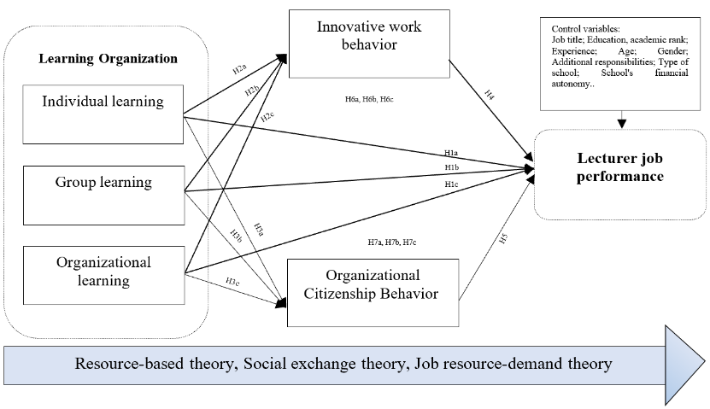
Figure 2.1: Proposed research model
Source: Author's suggestion
The proposed research model has several new points as follows:
First, LO is examined at the individual, group, and organizational levels, thereby enabling the distinct effects of each level on lecturers’ behaviors and JLP to be identified.
Second, the model examines both the direct and indirect effects of LO through two parallel mediating mechanisms: IWB represents the innovation pathway in job performance, whereas OCB represents the pathway of cooperation and voluntary contribution.
Third, the model integrates RBV, SET, and JD–R to explain, respectively, the role of LO as an organizational resource and capability, lecturers’ behavioral reciprocation, and the process through which learning resources are transformed into motivation, positive behaviors, and JLP.
Fourth, the model is developed and tested in the HE context, with lecturers as the research subjects, thereby providing additional empirical evidence on the relationships among LO, IWB, OCB, and JLP.

Chapter 3: CONTEXT, PROCESS AND RESEARCH METHODOLOGY
3.1. Overview of the university system and faculty in Hanoi city
3.1.1. Overview of the university system in Hanoi city
General picture of universities in Vietnam: In this dissertation, the term “university” is used collectively to refer to both universities and HE institutions designated as academies within the research scope. According to the Ministry of Education and Training’s 2025 Higher Education Conference Report, Vietnam’s higher education system comprises 11 multi-member universities, 173 public universities and academies, and 67 private universities and institutions with foreign involvement. During the 2023–2024 academic year, Vietnam had 243 universities, of which 176 were public institutions, reflecting the State’s leading role in higher education.
Scale and position of universities in Hanoi: According to statistics from the Ministry of Education and Training, in 2023-2024, Hanoi has 83 universities and academies (excluding universities and academies under the Security and National Defense sector), accounting for about 34.2% of the total HE institutions nationwide. Of these, 64 are public universities and academies and 19 are non-public. The student population of universities and academies in Hanoi is about 783,750 students in the academic year 2023-2024, accounting for 33.3% of the total university students in Vietnam, the highest in the country.
3.1.2. Overview of the faculty in universities in Hanoi city
Size of the university lecturer workforce in Hanoi: Alongside its large number of HE institutions and students, Hanoi is home to a substantial proportion of Vietnam’s university lecturers. According to 2025 data from the Ministry of Education and Training, Vietnam had 82,451 full-time lecturers, of whom 25,499 worked in Hanoi, accounting for approximately 30.9%. These lecturers work within a diverse system of institutions that differ in academic disciplines, ownership types, levels of autonomy, and governance models. Hanoi also has a high concentration of academic human resources. In 2025, 11,143 of its 25,499 full-time lecturers held doctoral degrees, representing 43.7%, compared with the national average of 35.7%. Hanoi was also home to 3,933 professors and associate professors, accounting for a substantial proportion of the 6,814 professors and associate professors across the national HE system.
Overview of LJP in universities in Hanoi: Regarding teaching performance and student support: Universities in Hanoi undertake a large volume of teaching, educating hundreds of thousands of students annually at undergraduate and postgraduate levels. Regarding scientific research, knowledge transfer, and other professional activities: Hanoi is home to most of the leading universities/institutes nationwide in terms of scientific publications, especially articles published in prestigious international journals, works belonging to the Scopus and Web of Science systems.
3.2. Research process
The dissertation implements a research process consisting of 10 steps (see Figure 3.1), ensuring a logical connection between theoretical overview, model building, data collection tool design, qualitative research, quantitative research, and research results discussion.
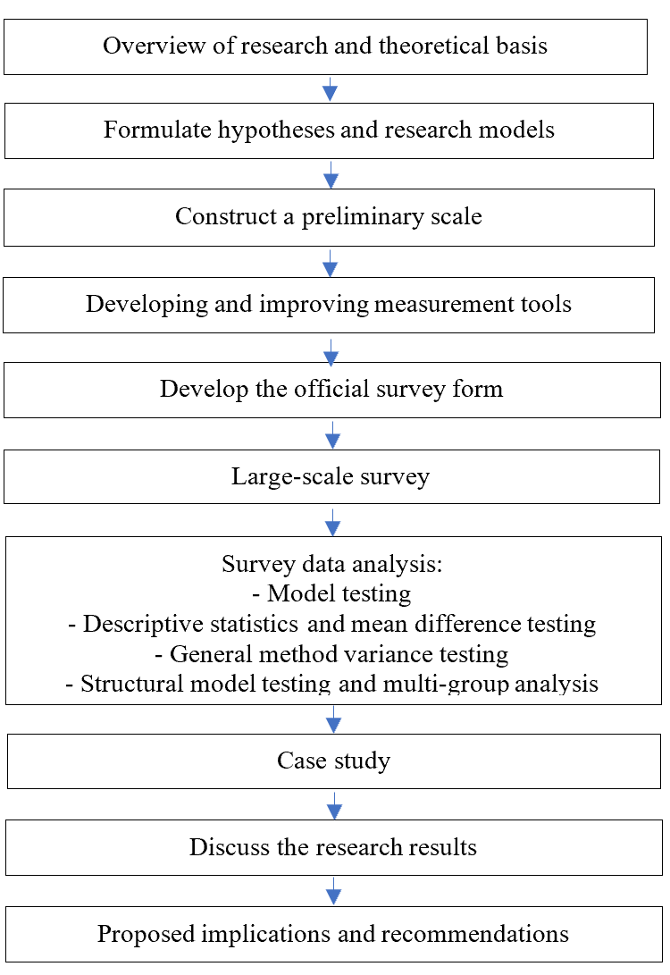
Figure 3.1: Research process
Source: Author's suggestion
3.3. Development of preliminary measurement scales for research variables
The initial LO scale was adapted from Marsick & Watkins (2003)'s 21-item version, with 6 observed variables at the individual level, 3 observed variables at the group level, and 12 observed variables at the organizational level.
The LJP scale used includes 7 observed variables selected based on inheritance and synthesis from studies by N. T. Pham-Thai et al. (2023), El Junusi et al. (2023), and Tuyet-Mai Nguyen et al. (2022).
The dissertation's IWB scale consists of 6 observed variables adapted from Hu et al. (2009), which is an adaptation of the scale developed by Scott and Bruce (1994).
The dissertation selected the scale by N. T. Pham-Thai et al. (2023), which was adapted and modified from Williams and Anderson (1991), with two components: OCB directed towards individuals (7 observed variables) and OCB directed towards the organization (7 observed variables).
3.4. Research methodology
The dissertation combines qualitative and quantitative methods. Of these, quantitative methods play a dominant role, used to test the research model and proposed hypotheses based on official survey data. Qualitative methods are used in a supplementary role to support the development and refinement of measurement tools and to help explain and clarify the quantitative research results.
3.4.1. Data collection methods
3.4.1.1. Literature review
The literature review method was used in the dissertation to collect, systematize, and analyze secondary information sources related to the research problem. This method was deployed throughout the research process, especially in the stages of forming the theoretical basis, building the research model, proposing research hypotheses, selecting measurement scales, and providing a basis for discussing research results.
3.4.1.2. Development and refinement of measurement tools
Based on the preliminary scales inherited from previous studies, the author proceeded to develop and refine the measurement tools to ensure that the observed variables were appropriate for the context of university lecturers in Hanoi. This process was carried out in two steps: expert interviews to review the content validity of the scales and a pilot survey to check the clarity and comprehensibility of the questionnaire before the official survey.
a. Expert interviews: Expert interviews were conducted with 05 purposively selected experts, all holding doctoral degrees or higher and having experience in teaching, scientific research, or management in HE. Discussions focused on the suitability of the observed variables with the research concepts, the clarity of the wording, and the relevance to lecturers' work context. The results showed that the preliminary scale was generally suitable, but some statements needed to be adjusted to be more concise, clear, less redundant, and more relevant to the HE context. Based on this, the author refined the scale for use in the pilot survey.
b. Pilot test: After expert interviews, the author conducted a pilot test with 10 lecturers working at different universities to check the clarity, comprehensibility, and ease of responding to the questionnaire. The results showed that most observed variables were relatively clear; however, some statements were further adjusted to be more specific, natural, and suitable for lecturers' understanding before deploying the official survey.
3.4.1.3. Official research data collection
a. Survey method
Questionnaire design: The questionnaire survey method was used to collect primary data for testing the research model and hypotheses of the dissertation. The questionnaire was designed into 05 parts: the first four parts measured the variables, respectively LO, LJP, IWB, and OCB; the last part collected demographic information and work characteristics of the respondents. The study used a 5-point Likert scale to measure the observed variables.
Sample design: The survey participants were full-time lecturers working at universities in Hanoi. The study did not survey visiting lecturers and did not include cases where individuals held only research positions without participating in teaching as full-time lecturers. Respondents needed to have sufficient practical experience of the working environment and professional activities within the university. The minimum sample size was 230 observations. The dissertation used a combination of purposive sampling and snowball sampling to reach the survey subjects.
Data collection: Data collection was carried out from October 2024 to December 2024 using two forms: direct survey with paper questionnaires and online survey via Google Forms. For online surveys, the author sent the survey link to accessible lecturers and asked them to share it within the same university; at the same time, separate links were created for each university to facilitate tracking the number of responses received. For direct surveys, paper questionnaires were distributed and collected immediately after respondents completed them, implemented at 27 universities. The data collection process was monitored weekly to control progress and sample structure by university type.
In total, the study collected 565 responses; after data cleaning, 523 valid responses were used for analysis, including 309 paper questionnaires and 214 online questionnaires. Invalid questionnaires were rejected because respondents had less than 01 year of service, many missing items, responded with a single level for all questions, or had duplicate responses. The final research sample consisted of 523 lecturers from 40 universities in Hanoi, including 29 public and 11 non-public universities. The sample structure shows a relatively wide coverage of surveyed units and university types, thereby reflecting the diversity of the research context; participating universities were coded to ensure information confidentiality.
Descriptive statistics of the survey sample: The results of descriptive statistics show that the survey sample has a relatively diverse structure in terms of professional title, educational level, age, teaching experience, degree of financial autonomy of the university, degree of concurrent positions, and gender. The sample mainly focuses on the group of lecturers, senior lecturers, with master's and doctoral degrees, aged 35 to 44, and with 10 years or more of teaching experience. This indicates that the survey sample is relatively consistent with the characteristics of the faculty in the research context.
b. Case study
Case studies were used to add depth to the analysis and interpretation of quantitative results, thereby clarifying the mechanism of LO's impact on IWB, OCB, and LJP in specific university contexts. The study was conducted at Thuongmai University and FPT University using a purposive sampling method. The selection of these two universities was based on a combination of similarity in development goals and differences in ownership type, governance mechanisms, and organizational characteristics, thereby providing a basis for comparison and deeper explanation of the research phenomenon.
The research content focuses on the university's operational context, manifestations of LO at various levels, conditions promoting IWB and OCB, and the relationship of these factors with LJP. Data were collected from secondary documents, public information, and semi-structured interviews with managers, HR staff, and lecturers knowledgeable about the university's operational context. The author interviewed 05 people at each university. The collected information was analyzed by case, then compared between the two universities and linked with quantitative results to support the interpretation of research findings and provide a basis for proposing management implications.
3.4.2. Data analysis
3.4.2.1. Qualitative data analysis
The qualitative data of the dissertation were collected from literature review, expert interviews, pilot testing of questionnaires, and case studies at FPT University and Thuongmai University. These data were not used to test hypotheses in a statistical sense, but mainly served to build a theoretical basis, refine measurement tools, clarify the research context, and support the interpretation of quantitative results. Specifically, data from literature review were selected, systematized, and analyzed by topic to identify concepts, research gaps, models, hypotheses, and preliminary scales. Data from expert interviews and pilot testing were synthesized, categorized, and compared according to main problem groups to revise and refine the scales and questionnaires. For case studies, information was coded and analyzed by topic, first within each case, then compared between the two cases to identify similarities and differences. In addition, qualitative data sources were also compared with each other and with quantitative results to increase the reliability and explanatory power of the study.
3.4.2.2. Quantitative data analysis
After collection, survey data were entered, merged, and cleaned before analysis. The analysis process was performed in three steps: (i) evaluating the measurement model; (ii) descriptive analysis and testing group differences using SPSS 20; and (iii) evaluating the structural model, testing mediating roles, and multi-group analysis using PLS-SEM on SmartPLS. The measurement model was evaluated through criteria of reliability, convergent validity, discriminant validity, outer loadings, and multicollinearity; common method bias was also checked. Next, SPSS was used for descriptive statistics of the sample, descriptive analysis of research variables, and testing for differences between lecturer groups using t-tests and ANOVA. Finally, the structural model was evaluated through path coefficients, bootstrapping, R² coefficient of determination, f² effect size, Q² predict predictive relevance, and multi-group analysis (MGA) in SmartPLS.

Chapter 4: RESEARCH RESULTS ON THE IMPACT OF LEARNING ORGANIZATION ON LECTURERS’S JOB PERFORMANCE IN UNIVERSITIES IN HANOI CITY
4.1. Results of scale validation through measurement model evaluation
4.1.1. Measurement model evaluation – Stage 1
After data cleaning, the study used 523 valid questionnaires to evaluate the measurement model using SmartPLS, focusing on the reliability, convergent validity, and discriminant validity of the scales. In the model, learning organization was treated at three levels, with individual learning and organizational learning as second-order variables; organizational citizenship behavior was also treated as a second-order variable comprising OCBI and OCBO. The results of the first evaluation showed that 02 observed variables did not meet the outer loading requirements, namely OCBI3 and OCBO3, and were therefore removed from the model. After removal, the re-run results showed that all remaining observed variables met the requirements. At the same time, all first-order constructs ensured reliability and convergent validity, with Cronbach's Alpha and CR ranging from 0.707 to 0.909, and AVE all greater than 0.50. Thus, the first-order scales met the requirements for further analysis.
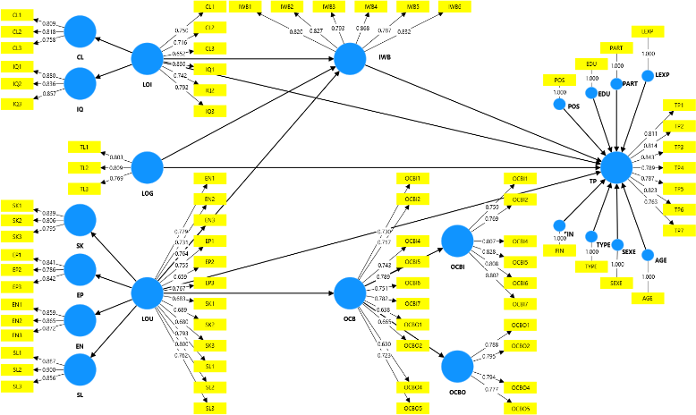
Figure 4.1: Outer loading results of first-order variables
Source: Author's analysis results
4.1.2. Measurement model evaluation – Stage 2
In Stage 2, the author continued to evaluate the measurement model for the constructs in the research model, where LOI, LOU, and OCB were treated as second-order variables. The results showed that the outer loadings of the component variables all met the requirements. At the same time, all second-order scales ensured reliability with Cronbach's Alpha and CR ranging from 0.780–0.897; all AVE values were greater than 0.50, confirming convergent validity. In addition, the results of discriminant validity testing according to the Fornell–Larcker criterion and the HTMT index all met the requirements, as the square root of AVE for each construct was greater than its correlation coefficient with other constructs, and all HTMT coefficients were less than 0.90. Thus, the measurement model in Stage 2 fully met the requirements for reliability, convergent validity, and discriminant validity.
4.2. Survey results on learning organization and lecturers’s job performance in universities in Hanoi city
Regarding descriptive statistics, all research variables were rated by lecturers as fairly high to very high, with mean values ranging from 3.98 to 4.44 and standard deviations from 0.47 to 0.59, indicating a relatively high level of agreement among responses. Among them, LJP had the highest mean value (Mean = 4.44), reflecting a tendency for positive self-assessment of task completion; conversely, group learning had the lowest mean value (Mean = 3.98) among the research variables, indicating that this aspect could be further strengthened in the context of lecturers' professional activities.
Regarding analysis of mean differences, the results showed differences in some surveyed groups, but these differences did not appear uniformly across all classification characteristics. Specifically, lecturers at public universities rated learning organization significantly higher at all three levels compared to lecturers at non-public universities; lecturers with no concurrent positions had higher levels of OCB, especially OCB directed towards the organization, than the group with concurrent positions; the 35–44 age group rated organizational learning higher than the 45–54 group; and in financially autonomous universities, OCB and OCBI were also higher. Meanwhile, variables such as gender, academic title/degree, professional title, and teaching experience did not show statistically significant differences.
Regarding case study results, research at TMU and FPT added depth to the quantitative findings, while clarifying how LO is formed and operates in different organizational contexts. At each university, the author interviewed 05 people, including 01 faculty/institute-level manager, 01 HR department staff, and 03 lecturers, thereby collecting information from both management and professional perspectives. The case study results showed that LO, IWB, and OCB were not only perceived at the cognitive level but also expressed through specific management practices, support mechanisms, training activities, and working environments of each university; thereby contributing to a deeper explanation of quantitative results and increasing the practical basis for the dissertation's management implications.
4.3. Results of model and hypothesis testing through structural model evaluation
4.3.1. Results of common method bias testing
To identify common method bias (CMV), the dissertation combined both procedural measures and statistical testing. Procedurally, the questionnaire was designed to ensure anonymity, not collecting personal identification information, and emphasizing the research purpose and confidentiality principles to reduce psychological pressure and the tendency to respond according to social expectations. Statistically, the study used Harman's single-factor test on SPSS 20; the results showed that the single factor explained only 36.927% of the variance, lower than the 50% threshold, indicating that CMV did not cause serious impact. At the same time, testing on SmartPLS showed that all VIF values were less than 3.3, further confirming no common method bias issues in the study.
4.3.2. Detecting multicollinearity
To test the structural model, the study used the Bootstrap procedure with 5,000 bootstrap samples in PLS-SEM at a 5% significance level. At the same time, multicollinearity was checked through the VIF index in the Inner VIF Values section on SmartPLS. The results showed that all VIF values were less than 3.0, indicating that the model did not suffer from significant multicollinearity. Thus, the estimates in the model were stable and met the conditions for performing subsequent analysis steps.
4.3.3. Testing the model and research hypotheses
The results of the structural model show that all hypotheses regarding direct effects were accepted; the three levels of LO all have a positive impact on LJP, IWB, and OCB. At the same time, both IWB and OCB have a positive impact on LJP, with OCB having a stronger direct influence. Regarding indirect effects, OCB demonstrates a clearer and more consistent mediating role compared to IWB; generally, all mediating variables play a partial mediating role, but the mediating role of IWB in the relationship between organizational-level learning and JLP (H6c) was not supported.
Table 4.15: Results of hypothesis testing
 | Giả thuyết | Hệ số chuẩn hóa beta | Độ lệch chuẩn | T - value | P -values | Kết quả kiểm định | f²
 | Tác động trực tiếp
 | LOI -> TP (H1a) | 0,136 | 0,045 | 3,002 | 0,003 | Chấp nhận | 0,017
 | LOG -> TP (H1b) | 0,121 | 0,051 | 2,368 | 0,018 | Chấp nhận | 0,013
 | LOU -> TP (H1c) | 0,115 | 0,054 | 2,152 | 0,031 | Chấp nhận | 0,011
 | LOI -> IWB (H2a) | 0,225 | 0,054 | 4,151 | *** | Chấp nhận | 0,034
 | LOG -> IWB (H2b) | 0,211 | 0,059 | 3,576 | *** | Chấp nhận | 0,028
LOU -> IWB (H2c) |  | 0,160 | 0,064 | 2,508 | 0,012 | Chấp nhận | 0,015
LOI -> OCB (H3a) |  | 0,229 | 0,047 | 4,863 | *** | Chấp nhận | 0,038
LOG -> OCB (H3b) |  | 0,244 | 0,064 | 3,800 | *** | Chấp nhận | 0,041
 | LOU -> OCB (H3c) | 0,178 | 0,067 | 2,670 | 0,008 | Chấp nhận | 0,020
 | IWB -> TP (H4) | 0,115 | 0,043 | 2,665 | 0,008 | Chấp nhận | 0,016
 | OCB -> TP (H5) | 0,393 | 0,053 | 7,355 | *** | Chấp nhận | 0,176
 | Tác động gián tiếp
 | LOI -> IWB -> TP (H6a) | 0,026 | 0,011 | 2,307 | 0,021 | Chấp nhận  (Trung gian một phần)
 | LOG -> IWB -> TP (H6b) | 0,024 | 0,012 | 2,014 | 0,044 | Chấp nhận  (Trung gian một phần)
 | LOU -> IWB -> TP (H6c) | 0,018 | 0,010 | 1,799 | 0,072 | Chưa khẳng định
LOI -> OCB -> TP (H7a) |  | 0,090 | 0,020 | 4,509 | *** | Chấp nhận  (Trung gian một phần)
LOG -> OCB -> TP (H7b) |  | 0,096 | 0,031 | 3,085 | 0,002 | Chấp nhận  (Trung gian một phần)
LOU -> OCB -> TP (H7c) |  | 0,070 | 0,029 | 2,413 | 0,016 | Chấp nhận  (Trung gian một phần)
Tổng tác động gián tiếp
LOI -> TP |  | 0,116 | 0,022 | 5,312 | ***
LOG -> TP |  | 0,120 | 0,033 | 3,634 | ***
LOU -> TP |  | 0,088 | 0,033 | 2,640 | 0,008
Tổng tác động
LOI -> TP |  | 0,252 | 0,049 | 5,132 | ***
LOG -> TP |  | 0,241 | 0,058 | 4,185 | ***
LOU -> TP |  | 0,204 | 0,055 | 3,715 | ***
Note: ***: p values < 0.001
Source: Author's analysis results
The model has a relatively good explanatory power, with R² = 0.279 for IWB, R² = 0.332 for OCB, and R² = 0.520 for LJP; it also has out-of-sample predictive validity, with all Q²_predict values were greater than zero..
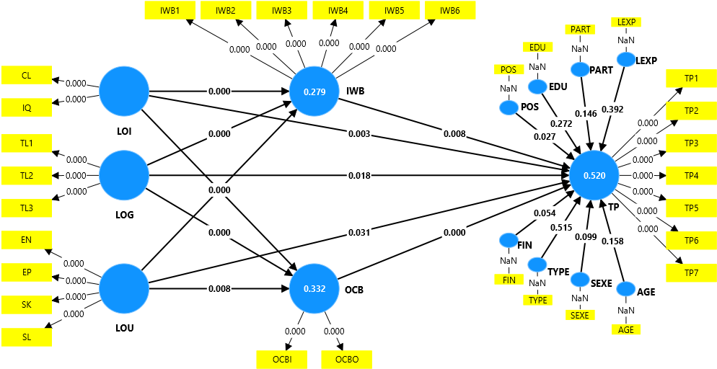
Figure 4.3: Results of structural model analysis
Source: Author's analysis results
Multi-group analysis results showed statistically significant differences only in some path coefficients, specifically the relationship from OCB to LJP by university type, and from individual learning to IWB by concurrent appointment status.
4.4. Discussion of research results
4.4.1. Overall picture of learning organization and lecturers’s job performance
The descriptive statistics results show that all research variables were rated by lecturers as fairly high to very high, with mean values ranging from 3.98 to 4.44; among them, LJP had the highest mean value (4.44). This finding indicates that in the context of universities in Hanoi, lecturers tend to have a positive self-assessment of their job performance, and also perceive relatively clearly the manifestations of LO, IWB, and OCB. This finding is generally consistent with previous studies in the HE context, where lecturers often have relatively high levels of professional responsibility, commitment, and positive behavior, but the level of organizational learning among different levels is not entirely uniform.
4.4.2. Direct impact of learning organization on lecturers’s job performance
The model testing results show that individual learning (β = 0.136; p = 0.003), group learning (β = 0.121; p = 0.018), and organizational learning (β = 0.115; p = 0.031) all have a direct, positive impact on LJP. Among them, individual learning has a slightly stronger impact than the other two levels. This result reinforces the arguments of Watkins and Marsick, and is consistent with studies by Egan, Yang & Bartlett (2004), Song, Joo & Chermack (2009), Joo (2010), and Yang et al. (2022) which all affirm that LO is an important resource for job performance.
4.4.3. Impact of learning organization on innovative behavior and organizational citizenship behavior
The research results show that all three levels of LO positively impact IWB and OCB. Specifically, individual learning has a stronger impact on IWB (β = 0.225; p < 0.001), while group learning has a more prominent impact on OCB (β = 0.244; p < 0.001). This result is consistent with social exchange theory and consistent with studies by Joo & Park (2010), Chang, Tsai & Tsai (2011), Joo, Park & Kim (2012), Lau et al. (2020), Umalihayati et al. (2022), showing that a learning and supportive environment in the organization is an important foundation for promoting positive professional behaviors beyond formal role requirements.
4.4.4. Role of innovative behavior and organizational citizenship behavior in lecturers’s job performance
The testing results show that IWB has a positive impact on LJP with β = 0.115; p = 0.008, while OCB has a stronger impact with β = 0.393; p < 0.001. At the same time, most indirect effects through IWB and OCB were supported, except for the indirect path from organizational-level learning to JPL through IWB. The model explains 27.9% of the variation in IWB, 33.2% of the variation in OCB, and 52.0% of the variation in LJP. This result is consistent with studies by Janssen (2003), De Jong & Den Hartog (2010) on the role of IWB, and reinforces the conclusions of Organ (1988, 1997) and Podsakoff et al. (2009) on the positive influence of OCB on job performance. Compared to many previous studies, a notable point of the dissertation is that it simultaneously tested these two mediating mechanisms in the same model and showed that OCB is a more prominent transmission channel in the context of lecturers in Hanoi.

Chapter 5: MANAGEMENT IMPLICATIONS AND RECOMMENDATIONS FOR APPLICATION OF RESEARCH RESULTS
5.1. Basis for proposing management implications and recommendations for application of research results
5.1.1. Context of innovation in university governance and the need to improve lecturers’s job performance
The dissertation's management implications and recommendations for application are primarily proposed from the current context of innovation in HE governance. Under conditions where universities are facing increasing pressure regarding autonomy, accountability, quality assurance, digital transformation, innovation, and international integration, the requirement to improve LJP has become increasingly urgent. At the same time, the need to build a learning environment, promote lifelong learning, and develop faculty towards adaptation, innovation, and cooperation also highlights the role of LO, IWB, and OCB in university governance.
5.1.2. Strategic orientations for higher education development in the period to 2030, vision to 2045
Besides the practical context, the management implications and application recommendations of the dissertation are also placed within the strategic orientations for the development of Vietnamese HE to 2030, with a vision to 2045. Major policies all emphasize the requirement for fundamental and comprehensive reform of education and training; developing HE towards autonomy linked with accountability; promoting digital transformation, innovation, international integration; and simultaneously building a learning society and fostering lifelong learning. Therefore, developing universities towards the LO model, promoting IWB, fostering OCB, and improving LJP not only have significance at the university level, but are also consistent with the development orientation of the entire Vietnamese HE system.
5.2. Perspectives for proposing managerial implications and recommendations for applying the research findings
The managerial implications and recommendations are proposed based on several perspectives. First, managerial implications and application recommendations must be derived directly from the core findings of the dissertation. Second, managerial implications should be approached from a systemic and multi-level perspective. Third, these implications should be linked to HRM in universities. Fourth, the recommendations should balance long-term orientation with immediate feasibility. Fifth, the implications should take into account differences among groups of universities and groups of lecturers.
Based on these orientations, the managerial implications and recommendations for applying the research findings in the following sections of this chapter are presented along two main axes. The first axis is the development of LO as a foundation for strategic university governance, through the enhancement of learning at the individual, group, and organizational levels. The second axis is the promotion of lecturers’ positive behaviors, particularly IWB and OCB, as direct mechanisms contributing to the improvement of JP in the current HE context.
5.3. Managerial implications for enhancing faculty job performance in universities in Hanoi
5.3.1. Developing learning organization as a governance foundation for faculty development
The research findings indicate that LO plays an important role in enhancing faculty JP and also affects JP through IWB and OCB. Therefore, universities in Hanoi need to develop LO as a foundation for faculty governance, in which learning is not merely a set of isolated training and development activities, but should be linked to human resource strategy, competence development, knowledge management, and performance management.
First, at the individual level, universities need to develop individual learning in connection with lecturers’ competence management and career development. Universities should clearly identify competence requirements for lecturers according to job positions, professional titles, career development stages, and institutional strategic orientations. On that basis, they should assess learning needs, develop annual individual learning plans, support the implementation process, and recognize learning outcomes based on their value when applied to work. The focus should not be on requiring lecturers to participate in many training courses, but on helping them transform learning outcomes into improvements in teaching, scientific research, learner supervision, learning material development, technology application, and professional contributions. For new and young lecturers, priority should be given to professional integration, academic mentoring, teaching competence, research competence, and digital competence. For experienced lecturers, their roles as mentors, academic reviewers, and knowledge disseminators within the unit should be promoted.
Second, at the group level, universities need to develop learning through professional learning communities and professional knowledge sharing. Faculties, departments, research groups, and professional groups should be organized as substantive learning spaces where lecturers exchange ideas, provide feedback, experiment with improvements, and support one another in their work. Professional meetings should be renewed toward reducing administrative formality and increasing academic and professional development content, such as sharing teaching experiences, commenting on course syllabi, reviewing manuscripts, conducting peer observation and feedback, developing learning materials, applying technology, supporting quality assurance, and promoting university–industry collaboration. In addition, knowledge generated through professional collaboration should be packaged, stored, and shared on common platforms so that it can be reused across the university. Group-level learning is an important bridge that helps transform individual learning into IWB, OCB, and better JP.
Third, at the organizational level, universities need to institutionalize learning within human resource strategy, knowledge management systems, and performance management. Organizational-level learning should be implemented through several key pillars, including faculty development strategy, competence frameworks and HR data, JP appraisal systems, digital infrastructure and shared knowledge repositories, and a culture of learning and continuous improvement. Universities should avoid fragmented and formalistic approaches to training and development. Instead, they need to build a learning management system in which learning needs, competence development plans, post-learning application outcomes, and JP evaluation are interconnected. At the same time, universities need to create a safe environment in which lecturers can share difficulties, experiment with new practices, learn from mistakes, and contribute knowledge to the academic community.
5.3.2. Promoting innovative work behavior and organizational citizenship behavior in faculty performance management
In addition to developing LO, universities need to promote lecturers’ IWB. IWB should be managed as a process that includes problem identification, idea generation, initiative proposal, experimentation, evaluation, adjustment, and diffusion. Universities need to identify innovation priorities aligned with their development strategies, such as innovation in teaching methods, digital transformation, AI application, innovation in assessment, development of digital learning materials, enhancement of learner experience, scientific research, university–industry collaboration, and community service. Lecturers’ initiatives do not necessarily need to be large in scale; they may begin with small improvements that can be tested quickly and create practical value. To sustain this behavior, universities need mechanisms to provide resources, professional feedback, recognition of initiatives, and dissemination of good practices.
At the same time, universities need to foster lecturers’ OCB in connection with a culture of support, motivation, and recognition of extra-role contributions. OCB is reflected in lecturers’ voluntary support for colleagues, sharing of learning materials, mentoring of young lecturers, participation in collective tasks, support for learners, and contributions to the development of faculties, departments, and the university. Since this behavior is voluntary, universities should not turn it into an administrative requirement or compulsory target. Instead, it should be nurtured through a fair, trustworthy, collaborative, and appropriately appreciative environment. In particular, universities need to control the risk of overload among lecturers who frequently participate in collective work, avoiding the overuse of voluntary spirit in ways that reduce motivation and negatively affect JP.
5.4. Conditions for ensuring the implementation of implications and recommendations
For the above implications to be implemented effectively, several conditions need to be ensured. First, university-level leaders must demonstrate a clear commitment to considering faculty development, learning, innovation, and organizational contribution as strategic priorities. Second, HR departments need to strengthen their professional capacity and shift from an administrative personnel role to an advisory and strategic partner role in faculty development. Third, universities need to ensure resources in terms of budget, time, data, technological infrastructure, and academic spaces for learning, innovation, and knowledge-sharing activities. There should be clear coordination mechanisms among university-level leaders, HR departments, functional departments, faculties/departments, and lecturers. Fourth, it is necessary to establish a mechanism for monitoring, feedback, and continuous improvement throughout the implementation process. When these conditions are ensured, learning organization will become an organizational capability of the university, contributing to enhanced faculty job performance, promoting IWB, fostering OCB, and strengthening universities’ adaptability in the context of HE reform.
CONCLUSION
The dissertation was conducted to study the impact of LO on LJP in universities in Hanoi, while also examining the mediating role of IWB and OCB. Based on a combination of qualitative and quantitative research, the dissertation has achieved several key results.
First, the dissertation systematized and clarified the theoretical basis of LO, IWB, OCB, and LJP; and proposed and tested a research model reflecting the impact of LO at three levels on LJP through two mediating mechanisms: IWB and OCB. The research results show that LO at all three levels has a direct positive impact on LJP; and most indirect effects through IWB and OCB were supported, except for the indirect path from organizational-level learning to JLP through IWB. Among them, individual-level learning has the strongest direct impact; group-level learning plays a prominent role in transforming the learning environment into lecturer behavior and JP; and organizational-level learning provides the foundation for the environment, mechanisms, and orientation for other learning levels to be effective.
A notable finding of the dissertation is that OCB has a stronger impact than IWB on LJP. This suggests that, in universities, in addition to the requirement for innovation, behaviors such as supporting colleagues, participating in common work, adhering to organizational responsibilities, and contributing beyond formal requirements are very significant for LJP. The dissertation also found some differences among groups of lecturers and types of universities, thereby indicating that management solutions need to be adjusted to suit the context of each university and each target group.
Based on this, the dissertation proposes management implications and application recommendations aimed at improving LJP, focusing on two main directions: developing LO as a strategic management foundation and promoting positive professional behaviors, especially IWB and OCB.
In addition to its achieved results, the dissertation still has several limitations. First, the study employs a cross-sectional design, which limits its ability to infer causal relationships and examine changes over time. Second, the quantitative data are mainly based on lecturers’ self-assessments; therefore, they may be affected by perceptual bias and common method bias, although the dissertation has applied several control measures in the research design and data collection process. Third, the survey scope is limited to universities in Hanoi, and the sampling approach combines convenience, purposive, and network-based extension methods; therefore, the generalizability of the findings to the entire Vietnamese HE system should be considered with caution. Fourth, several external variables, such as academic discipline, work pressure, degree of autonomy, leadership style, faculty/department culture, and the resource conditions of each university, have not been fully explored. In addition, the number of case studies remains limited, so the qualitative findings mainly serve to illustrate, support, and clarify the research context. Based on these limitations, future studies may expand the survey scope to multiple localities, improve the sampling design, test for non-response bias, combine multiple data sources beyond lecturers’ self-assessments, employ longitudinal research designs, and incorporate additional control variables, moderating variables, or mediating variables to further clarify the mechanisms affecting LJP in the HE context.

LIST OF PUBLISHED SCIENTIFIC WORKS
RELATED TO THE DISSERTATION TOPIC

1. Ngo Thi Mai (2026), The mediating role of person-organizational fit in the relationship between learning organizations and the lecturers’ job performance in Vietnamese universities, Journal of Trade Science, No. 210, February 2026, 220-232.
2. Ngo Thi Mai (2026), The impact of learning organizations on the lecturers’ job performance in public universities in Vietnam and the mediating role of organizational citizenship behavior, Economic and Financial Research online, No. 101, January 2026.
3. Ngo Thi Mai (2025), The impact of learning organizations on the lecturers’ job performance: The role of innovative behavior, Journal of Trade Science, No. 197/2025, 101-116.
4. Ngo Thi Mai (2024), Research on learning organization models in the world and in Vietnam, Economy and Forecast Review/No.8, 4/2024, 161-163.

