MINISTRY OF EDUCATION AND TRAINING
THUONGMAI UNIVERSITY
------------------------------

NGUYEN MINH DUC

RESEARCH ON KNOWLEDGE TRANSFER
IN VIETNAMESE ENTERPRISES

Major: Business Administration
Code: 9340101

ABSTRACT OF THE DOCTORAL DISSERTATION
IN ECONOMICS

Hanoi, 2026

This dissertation was completed at Thuongmai University

Supervisors:
Supervisor 1: Assoc. Prof., Dr. Nguyen Van Minh
Supervisor 2: Dr. Tran Hoai Nam

Reviewer 1: Assoc. Prof., Dr. Dinh Van Thanh

Reviewer 2: Assoc. Prof., Dr. Mai Thanh Lan

Reviewer 3: Dr. Luong Minh Huan

The dissertation will be defended before the University-level Dissertation Evaluation Council convening at Thuongmai University
At…………….. on……………………., 2026

The dissertation can be accessed at:
The National Library
The Library of Thuongmai University

LIST OF PUBLICATIONS BY THE DOCTORAL CANDIDATE RELATED TO THE DISSERTATION TOPIC

- Nguyen Van Minh, Tran Hoai Nam, Nguyen Minh Đuc, Hoang Hai Ha (2022), Knowledge Management in Enterprises in the Digital Era Hanoi Publishing House (NXB Hà Nội).
- Tran Hoai Nam, Nguyen Minh Duc, Application of Information Technology-Based Knowledge Management Tools in Vietnamese Enterprises, The Journal of Economics and Forecasting (ISSN 1859-4972), Issue 16, June 2022.
- Nguyen Minh Duc, Tran Hoai Nam, Application of Augmented Reality Technology in Knowledge Transfer and Recommendations for Vietnamese Enterprises, The Finance Journal (ISSN 2615-8973), Issue 2, March 2024.
- Nguyen Minh Duc, Tran Hoai Nam, Some Solutions for Knowledge Transfer in E-Commerce Enterprises in Vietnam, Journal of State Management (ISSN e2815-5831), June 2024.
- Tran Hoai Nam, Nguyen Minh Duc, Nguyen Thi Bich Ha, Current Situation and Some Recommendations on Knowledge Sharing Activities in Vietnamese Enterprises, The Journal of Economics and Forecasting (ISSN 1859-4972), Issue 8, April 2024.
- Nguyen Minh Duc, Nguyen Van Minh, Trends in Applying Electronic Collaboration Tools to Knowledge Transfer Activities in Vietnamese Enterprises, The Journal of Economics and Forecasting (ISSN 1859-4972), Issue 1, March 2025.

INTRODUCTION
1. The Rationale for the Dissertation Topic
In the era of globalization and intensive digital transformation, knowledge has emerged as a strategic asset, dictating the competitive advantage and sustainable development of Vietnamese enterprises. Knowledge Transfer (KT) is no longer an option but a prerequisite for these enterprises to adapt and thrive. However, many Vietnamese firms lack a systematic Knowledge Management (KM) framework, leading to the loss of valuable tacit knowledge when employees resign or fail to share information effectively. Furthermore, the National Digital Transformation Program (toward 2025-2030) and the Resolution of the 13th National Congress have placed significant pressure on businesses: they must not only adopt new technologies but also establish a robust knowledge foundation to foster adaptability and innovation.
From a theoretical perspective, these models have not been fully adapted to the Vietnamese environment, characterized by rigid hierarchical structures, technological constraints, and a "knowledge hoarding" mentality due to the fear of losing personal influence. Current research in Vietnam remains generalized, lacking specific models and solutions tailored to the unique characteristics of local firms, such as financial constraints, human resource limitations, and infrastructure gaps. Therefore, this thesis is essential to fill this gap by developing an adjusted KT model that integrates internal factors like organizational culture and technology, thereby enriching KM theory within the context of an emerging economy.
From a practical standpoint, effective KT enables Vietnamese enterprises to optimize operations, drive innovation, and strengthen their global standing. Conversely, outdated technology and a shortage of high-quality labor increase the risk of falling behind. Without mastering new knowledge, businesses will struggle to meet international market demands and miss opportunities for sustainable growth. To achieve the goal of the digital economy accounting for a significant share of GDP by 2030, it is crucial to promote applied research that offers practical solutions aligned with Vietnam's socio-economic and cultural landscape. The thesis, "Research on Knowledge Transfer in Vietnamese Enterprises," addresses these urgent practical needs, helping businesses overcome barriers, adapt to digital transformation, and contributing scientific insights to elevate Vietnam’s position in the global race.
2. Research Objectives and Tasks
Research Objective
Theoretical: Systematizing and developing theoretical foundations of knowledge and knowledge transfer; building a research model of 05 factors affecting knowledge transfer suitable for Vietnamese enterprises' characteristics.
Practical: Assessing the current state of knowledge transfer in Vietnamese enterprises; verifying the impact level of factors in the research model through empirical data; proposing a synchronized, feasible system of solutions by enterprise scale (small, medium, large) to optimize knowledge transfer efficiency, enhance competitiveness, support digital transformation, and contribute to building a sustainable knowledge economy.
Research Tasks
- Systematizing theories and literature review on knowledge transfer (KT).
- Researching the current state and evaluating 05 factors affecting KT in Vietnamese enterprises.
- Proposing a KT model suitable for Vietnam's characteristics and a specific, feasible system of solutions by enterprise scale.
3. Research Object and Scope
Research Object
Regarding the subject, the thesis focuses on investigating internal knowledge transfer processes, analyzing five key influencing factors: knowledge source, organizational structure, organizational culture, people, and tools, while proposing a transfer model based on the SECI framework.
Research Scope
In terms of space, the research was conducted in Vietnam, with a survey sample primarily from three economic hubs representing three regions: Hanoi, Ho Chi Minh City, and Da Nang.
In terms of time, the study utilizes primary data collected since 2023, combined with secondary data and desk research materials published to date, ensuring current relevance and contextual fit.
In terms of content: Limited to internal knowledge transfer (subjects include individual-to-individual and individual-to-organization), without delving into inter-firm transfer or other knowledge management aspects like creation or protection.
The research subjects are Vietnamese enterprises operating in key economic sectors, with diverse characteristics in scale, organizational structure, and levels of technological application.
4. Research Methodology
To conduct the thesis, the author combines both qualitative and quantitative methods, along with primary and secondary research, to ensure scientific rigor and practical relevance. This section will be presented in detail in Chapter 2.
5. New Contributions of the Dissertation
Theoretical Contributions
The thesis has made several theoretical contributions, focusing on building a conceptual framework, analyzing the nature and characteristics of knowledge, knowledge transformation processes, influential factor models, and testing methods, thereby enriching the theoretical foundation of KT in Vietnamese enterprises. Specifically, theoretical highlights include:
Establishing a comprehensive theoretical framework on knowledge and KT in Vietnamese enterprises: The thesis systematized a clear theoretical framework for knowledge and KT. It also analyzed knowledge characteristics to clarify the multi-dimensional nature of organizational knowledge. The framework's core is knowledge classification and a three-stage knowledge transformation process. The author analyzed KT tools based on various criteria, providing a theoretical basis for selecting tools suitable for the Vietnamese context, where tacit knowledge prevails despite the lack of systematic storage. Additionally, the author synthesized and proposed a Comprehensive Model of Corporate KT.
Establishing a model of factors affecting KT in Vietnamese enterprises: The thesis established a model of factors influencing knowledge transfer, adjusted to match the practical situation of Vietnamese firms. The model includes 05 key factors: knowledge source (KS), organizational structure (OS), organizational culture (OC), people (PE), and tools (TO), along with corresponding research hypotheses. In this study, the author designed and calibrated scales for independent and dependent variables to ensure suitability with the research timing, objectives, and content.
Practical Contributions
Clarifying KT characteristics in Vietnamese enterprises: The thesis analyzes knowledge transfer through socialization, externalization, combination, and internalization stages, alongside key supporting factors like organizational culture and technology. Survey results from 418 enterprises in Vietnam's developed economic regions confirm that knowledge source, organizational culture, people, and tools are vital components for improving KT efficiency, thereby enhancing competitive advantage and performance. Notably, the study identifies tools and people as the two most influential factors, reflecting digital transformation trends and the role of individual knowledge in the Vietnamese context. Given the scarcity of in-depth research on these traits in Vietnam, the thesis provides a clear, comprehensive practical perspective for corporate reference.
Assessing the current state and proposing KT solutions for Vietnamese enterprises: The thesis evaluates and highlights strengths and limitations in current KT practices. Strengths include technological advancement and increasing awareness of knowledge importance. However, significant constraints remain, such as hierarchical organizational structures, lack of systematic knowledge storage, and a psychological reluctance to share within domestic firms.
Based on this reality, the thesis proposes several feasible solutions for Vietnamese enterprises to refine KT activities: building technology-based integrated knowledge management systems; restructuring culture and organization to support sharing; enhancing human capacity and intergenerational transfer; and strengthening cross-industry and government cooperation. These solutions go beyond orientation, demonstrating practical feasibility tailored to Vietnamese business conditions.
Additionally, the author proposes a KT model suitable for Vietnam, integrating the four SECI stages with Szulanski’s framework, supported by culture and technology. This practical solution helps Vietnamese enterprises optimize internal knowledge resources and effectively adapt to the digital transformation process.
Recommendations for State Agencies and Professional Associations
In terms of practical implications, the thesis proposes a system of specific, feasible solutions directed at state management agencies and relevant professional associations to catalyze knowledge transfer activities in Vietnam. This represents a significant practical contribution, providing a vital reference for regulators and professional bodies in formulating supportive policies to enhance organizational knowledge transfer efficiency.
6. Dissertation structure
The dissertation is systematically organized, comprising the Introduction, the main content presented in four chapters, and the Conclusion, References, and Appendices. This structure comprehensively covers all necessary aspects - from theoretical foundations, current status, to solutions - meeting scientific requirements and aligning with the research objective on knowledge transfer in Vietnamese enterprises. Specifically, the chapters are arranged as follows:
- Chapter 1: Literature Review and Theoretical Framework of Organizational Knowledge Transfer.
- Chapter 2: Research Methodology and Overview of the Research Subject.
- Chapter 3: Current Status and Analysis of Knowledge Transfer Activities in Vietnamese Enterprises.
- Chapter 4: Recommendations and Solutions for Promoting Knowledge Transfer in Vietnamese Enterprises.

CHAPTER 1: LITERATURE REVIEW AND THEORETICAL FRAMEWORK
OF ORGANIZATIONAL KNOWLEDGE TRANSFER.
1.1 Literature Review of Knowledge Transfer
1.1.1 Studies on Theoretical Frameworks and Models of Knowledge Transfer
Nonaka & Takeuchi’s (1995) SECI model delineates a four-stage spiral-socialization, externalization, combination, and internalization-emphasizing a knowledge-creating culture suitable for Japan but constrained in emerging economies by individual barriers. Szulanski (2000) proposes a four-stage linear process focusing on "stickiness" stemming from knowledge complexity and motivational deficits. Graham et al. (2006) categorize contexts connecting SECI to healthcare; Herfeld & Lisciandra (2019) analyze three core components highlighting cultural distance; Argote & Ingram (2000) link transformation-barriers via social networks and organizational structures.
In Vietnam, Nguyen Ngoc Thang (2010) analyzes SECI through Honda-Toyota, noting that collective culture fosters socialization while hierarchy hinders externalization, requiring supplementary limited resources. Napier (2005) proposes an internal-external four-factor framework adding culture to Szulanski’s model, yet lacks depth in digital technology (Dang Thi Viet Duc, 2023). Pham Quoc Trung & Dinh Xuan Kieu (2020) test Szulanski’s model, finding "stickiness" lacks trust but integrating collective culture mitigates barriers. Nham Phong Tuan et al. (2019) apply SECI to telecommunications, emphasizing online technology-sharing culture, which is limited for SMEs. Nguyen Duy Toan (2013) links SECI to competitive advantage, pointing out scale-based gaps.
Compared to international studies (multi-dimensional abstract theories), Vietnamese research leans towards specific industry applications but lacks compatible new models. This creates a significant gap: Vietnamese enterprises require simplified, applicable models that leverage collective culture to drive socialization, while overcoming resource constraints, organizational hierarchy, and low digitization to enhance knowledge transfer efficiency during digital transformation.
1.1.2 Studies on Barriers and Challenges in Knowledge Transfer
International research multidimensionally analyzes intrinsic barriers: tacit knowledge loss due to retirement (Whyte & Classen 2012, Cox & Overbey 2023), reduced communication post-COVID (Reit 2022), cross-border cultural differences (Charron 2022), low engagement and knowledge complexity (Grum & Gronau 2021), and "stickiness" from motivational or trust deficits (Szulanski 2000). Trends shift from individual to organizational, cultural, and procedural factors, yet lack focus on post-pandemic dynamics and digitalization.
In Vietnam, studies emphasize local barriers linked to culture and limited resources: loss due to personnel turnover (T. Nguyen & Burgess 2014), organizational-individual asymmetry (Dong et al. 2010), cultural distance in FDI (Pham Quoc Trung & Dinh Xuan Kieu 2020), risk perception hindering sharing (Nham Phong Tuan et al. 2019), short-term priorities and talent shortages (Molnar et al. 2011), low localization (Truong Thi Chi Binh & Nguyen Manh Linh 2013), limited awareness and incompatible culture (Vu Hong Dan 2008), post-COVID knowledge leakage due to lack of systems (Nguyen Thi Phuong Linh 2019), risk-aversion psychology (Tran Hoai Nam 2015), and limitations in advanced ICT (Dang Thi Viet Duc 2023).
Comparatively, Vietnam underscores local culture and resource constraints. While these two research directions are connected, gaps remain: international studies lack focus on post-COVID impacts and generational gaps, while Vietnamese research lacks quantitative assessment of digital technology and comprehensive solutions. This necessitates a compatible model to bridge these gaps and propose practical solutions for resource-constrained enterprises.
1.1.3 Studies on the Role of Technology in Knowledge Transfer
International research approaches the role of technology in KT through a multidimensional lens, aiming to overcome "stickiness" (Szulanski, 2000) and limitations in face-to-face interaction. Liu & Zhao (2009) emphasize information technology and organizational culture as pivotal in knowledge networks; Dohn et al. (2020) focus on educational technology alongside social interaction strategies; Rodríguez-López & Sucar (2022) utilize probabilistic graphs for precise prediction; Badila et al. (2020) propose remote software; Alavi & Leidner (2001) provide KMS for storage; and Bhatt (2001) links technology with culture and people. Trends have shifted from purely technical to holistic socio-technical perspectives, yet lack depth in data security.
In Vietnam, Tran Hoai Nam (2016) optimizes production processes; Nguyen Duy Toan (2013) develops ICT frameworks for SMEs to reduce leakage; Pham Thi Bich Ngoc (2017) surveys VINASA, indicating that ease of use influences frequency; Pham Quoc Trung & Huynh Minh Chau (2018) identify e-learning factors; Nguyen Van Minh et al. (2022) emphasize storage in the digital era; Dang Thi Viet Duc (2023) records basic ICT at 96% but advanced levels at only 6-7%; Le & Tran (2022) supplement e-learning to bridge distances with a learning culture. These practical studies are more applied than international counterparts but lack advanced modeling.
Comparatively, international research is theoretically diverse and comprehensive, while Vietnamese studies focus on specific industry applications but lack a generalized assessment of technology's role. Vietnamese solutions are often orientation-based, lacking simple, low-cost tools compatible with limited resources and collective culture. This creates a significant gap: the need for a model integrating technology with local culture, providing practical solutions for SMEs during digital transformation.
1.4 Studies on the Effectiveness and Benefits of Knowledge Transfer
Effective KT yields substantial benefits for enterprises, as extensively documented in international research: enhancing productivity, innovation, and sustainable competitive advantage (O’Dell & Jackson Grayson, 1999); linking social knowledge management directly to competitive edge (Chuang, 2004); and driving employee satisfaction, revenue, and profit through executive capabilities (Lara & Mártir, 2008). Knowledge resource management is identified as a key determinant of competitive advantage (Ali et al., 2009), showing a positive correlation with organizational performance (Rašula et al., 2012). Furthermore, it dictates success and sustainable succession (Leonard-Barton et al., 2014), reinforces practical learning (Dohn et al., 2020), and improves market adaptability (Fernandes et al., 2006). The synthesis of knowledge creates new value (Nonaka & Toyama, 2003) and improves efficiency when integrated with technology and culture (Lee & Choi, 2003).
In Vietnam, research confirms specific benefits but focuses more on general knowledge management than pure transfer: it is a core factor for multidimensional success (Thi Nguyet Que, 2010); knowledge creation capability determines the financial performance of SMEs (Nguyen Hoang Viet, 2011); and it positively impacts operational efficiency, with larger firms performing better (Thach Keo Sa Rate & Luu Tien Thuan, 2014). It also facilitates more effective risk-taking in banking (Hoang Hai Yen, 2015) and boosts individual-organizational innovation in telecommunications (Nham Phong Tuan et al., 2020). While the impact is positive, results vary across scales (Vu Ngoc Xuan, 2019). Creative marketing knowledge influences innovation in IJVs (Truong Quang Do, 2014), fosters creativity (Pham Anh Tuan, 2015), and increases university operational efficiency (Nguyen Thi Thu Ha, 2021), while family businesses maintain sustainable growth through collective culture (Bell & Pham Thanh Trung, 2021).
Vietnamese studies are often confined to specific sectors (telecom, education, family business) and lack a generalized assessment of KT across all industries, failing to clarify how to overcome barriers to optimize efficiency during digital transformation. This creates a significant gap: while potential benefits-productivity, innovation, competition, and adaptability-are high, they are hindered by hierarchical culture, limited resources, and a lack of concrete solutions. There is a pressing need for simplified models that leverage collective culture and low-cost technology to maximize these benefits, driving sustainable development for SMEs in the knowledge economy.

1.1.5 Studies on Factors Influencing Knowledge Transfer
International research identifies various factors influencing KT: Gold et al. (2001) emphasize infrastructure (organizational structure, culture, and tools) and continuous processes; Lee & Choi (2003) highlight socio-technical interactions; Davenport & Prusak (1998) point to culture, motivation, and tools (both technological and non-technological); Nonaka & Takeuchi (1995) through the SECI model focus on tacit knowledge transformation across four stages; Szulanski (1996) adds "stickiness" derived from complexity and motivational deficits; Lin (2007) affirms that trust and rewards drive sharing; Alavi & Leidner (2001) emphasize KMS for storage; and Whyte & Classen (2012) highlight storytelling as a support for tacit knowledge in small organizations.
In Vietnam, Tran Hoai Nam (2015) identifies awareness, motivation, culture, and tools as critical factors in SMEs; Pham Quoc Trung & Dinh Xuan Kieu (2020) emphasize that traditional hierarchical culture hinders sharing; Nham Phong Tuan et al. (2019) indicate that personal and peer motivation drive transfer, while fear of losing competitive advantage acts as a deterrent; Nguyen Thi Phuong Linh (2019) asserts that trust and motivation are pivotal; Nguyen & Burgess (2014) highlight internal knowledge sources as vital for SMEs; Tran & Pham (2020) show that rigid structures reduce efficiency; and Le & Tran (2022) record that technological tools are effective in large firms, whereas non-technological ones are more prevalent in SMEs.
Both international and Vietnamese studies provide a solid foundation for five key factors (knowledge source, organizational structure, organizational culture, people, and tools) and their relationship with barriers. However, direct application of international models to Vietnam remains challenging due to hierarchical culture and resource constraints. The author synthesizes Table 1.1 to analyze these factors within the Vietnamese context, establishing a scientific basis to propose practical solutions suitable for the modern knowledge economy.
Table 1.1: Summary of Factors Influencing KT from Previous Scientific Studies
No. | Factors | Key References | Notes
1 | Knowledge Source (KS) | Nonaka & Takeuchi (1995); Alavi & Leidner (2001); Wiig (1997); Markus (2001); Grant (1996); Szulanski (1996); Lin (2007); Nguyen & Burgess (2014) | Provides the knowledge foundation. Availability and diversity enhance transfer efficiency.
2 | Organi-zational Structure (OS) | Burns & Stalker (1961); Hitt et al. (2007); Gold et al. (2001); Tsai (2002); Lee & Choi (2003); Tran & Pham (2020) | Dictates the flow of information. Flexible structures facilitate effective communication.
3 | Organi-zational Culture (OC) | De Long & Fahey (2000); Nonaka & Takeuchi (1995); Van den Hooff & De Leeuw van Weenen (2004); Hofstede (2001); Pham Quoc Trung & Dinh Xuan Kieu (2020); Pham Quoc Trung & Huynh Minh Chau (2018) | Shapes sharing behaviors. An open culture fosters higher efficiency.
4 | People (PE) | Nonaka & Takeuchi (1995); Szulanski (1996); Levin & Cross (2004); Gold et al. (2001); Argote & Ingram (2000); Nguyen & Tran (2019); Nguyen Thi Phuong Linh (2019) | The nucleus of knowledge creation and transfer. Individual motivation and competence are decisive factors.
5 | Tools (TO) | Alavi & Leidner (2001); Goodhue & Thompson (1995); Bhatt (2001); Whyte & Classen (2012); Davenport & Prusak (1998); Le & Tran (2022); Nguyen & Burgess (2014) | Support knowledge storage and distribution. Inte-gration of technological and non-technological tools optimizes the process.
Source: Compiled and synthesized by the author
1.2 Research Gaps and Research Questions
1.2.1 Research Gaps
- The theoretical foundation of knowledge transfer (KT) has not been systematized, lacking a comprehensive theoretical framework.
- There is a lack of a holistic evaluation regarding the 05-factor model affecting KT within the Vietnamese context.
- Limitations exist in surveying the current state and clarifying the specific characteristics of KT activities in Vietnamese enterprises.
- A comprehensive and feasible system of solutions, tailored to the scale of Vietnamese enterprises, has yet to be established.
- Policy support proposals and recommendations for state management agencies regarding KT in Vietnamese enterprises remain insufficient in existing research.
1.2.2 Research Questions
Based on the identified gaps, the study proposes the following research questions:
1. How can a comprehensive theoretical framework for knowledge and KT be developed that aligns with the cultural, economic, and technological landscape of Vietnamese enterprises?
2. Which factors influence KT in Vietnamese enterprises, and how can an adjusted factor model be established alongside research hypotheses and scales designed and calibrated to ensure high suitability and reliability?
3. How are the characteristics of the KT process in Vietnamese enterprises manifested through the stages of socialization, externalization, combination, and internalization, integrated with the influence of organizational culture and technology, and how can these characteristics be clarified through empirical surveys?
4. What are the specific strengths and limitations of the current state of KT in Vietnamese enterprises, and how can a comprehensive, feasible system of solutions be proposed that is tailored to enterprise scale and integrated with key supporting factors to optimize KT activities?
5. What specific and feasible solutions can be proposed to state management agencies and professional associations to promote KT activities in Vietnamese enterprises, and how can synergy and alignment with existing national policies be ensured?
1.3 Theoretical Framework of Knowledge Transfer on Organizations
1.3.1 Overview of Knowledge
The Concept of Knowledge: The author defines knowledge as specialized understanding acquired through research and practice, integrating skills, attitudes, values, and insights derived from environmental interaction, where its value is fundamentally dependent on practical application.
1.3.2 Concepts and Classification of Organizational Knowledge
1.3.2.1 The Concept of Organizational Knowledge
Organizational knowledge is an accumulation of information, experience, skills, and insights that are managed to facilitate problem-solving, decision-making, and value creation - extending far beyond raw data.
1.3.2.2 Classification of Organizational Knowledge
Organizational knowledge is fundamentally categorized into three components of intellectual capital: Human Capital; Structural Capital; Relational Capital
1.3.3 Knowledge Transfer and Role in Organizations
1.3.3.1 The Concept of Knowledge Transfer
In this dissertation, the concept of knowledge transfer is adopted from the definition by Nguyen Van Minh et al. (2022): “Knowledge transfer is the process of communicating knowledge (experiences, lessons learned, know-how, etc.) from one source to another and the subsequent utilization of that knowledge.”
Knowledge transfer within an enterprise primarily refers to the activities where a source (the transferor) communicates content to a recipient (the transferee) through various tools (technological or non-technological). This process can be conceptualized as shown in Figure 1.3, where the overall model comprises the following components:
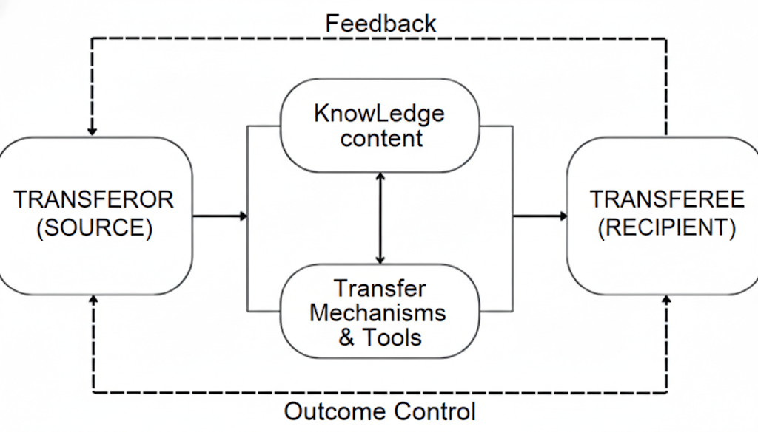
Source: Compiled and synthesized by the author
Figure 1.3: Conceptual Framework of Organizational Knowledge Transfer
1.3.5 Types and Tools of Organizational Knowledge Transfer
1.3.5.1 Types of Organizational Knowledge Transfer
Based on the classification of knowledge by manifestation (tacit and explicit), there are four primary types of knowledge transfer within an organization: Sequential Knowledge Transfer within a Group; Explicit Knowledge Transfer between Groups; Tacit Knowledge Transfer; Intergenerational Knowledge Transfer
1.3.5.2 Organizational Knowledge Transfer Tools
- Classification by Transfer Method
- Classification by Purpose of Use
- Classification by Technological Platform
- Classification by Type of Knowledge
1.3.6 Subjects and Content of Organizational Knowledge Transfer
1.3.6.1 Subjects of Organizational Knowledge Transfer
- Individuals (Employees)
- Workgroups (Teams)
- Departments/Functional Units
- Leadership/Management
1.3.6.2 Content of Organizational Knowledge Transfer
The content of organizational KT is a core process aimed at ensuring the effective retention, transmission, and application of various knowledge types to enhance value and competitiveness. Thus, the content of KT is not merely sharing information but encompasses: Identifying the knowledge required for transfer; Selecting the appropriate recipients; Determining the processes and tools for transfer; Executing the transfer process; Evaluating the effectiveness of the transfer activities.
1.3.7 Factors Influencing Knowledge Transfer in Organizations
Nonaka & Takeuchi (1995) describe this process as a "knowledge spiral," where cultural and human factors serve as the epicenter for converting individual insights into organizational intelligence. Davenport & Prusak (1998) supplement this by stating that knowledge is a fluid mix of framed experience, values, and contextual information, and that transfer effectiveness depends heavily on the ability to eliminate organizational barriers. Furthermore, Dalkir (2005) emphasizes key enablers that support knowledge sharing, while Tiwana (2000) and Awad & Ghaziri (2004) provide practical approaches for integrating these elements into a cohesive system. Synthesizing these authoritative sources, five core factors can be identified as the primary determinants of knowledge transfer efficiency. Each of these factors plays a distinct yet interconnected role, collectively forming an effective knowledge transfer system within the enterprise.
1.3.8 Knowledge Transfer Models in Organizations
1.3.8.1 Szulanski’s Communication Model of Knowledge Transfer
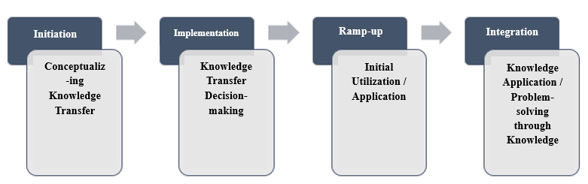
Figure 1.5: The Communication Model of Organizational Knowledge Transfer
Sourrce: Szulanski (2000)
1.3.8.2 The SECI Model of Knowledge Transfer by Nonaka and Takeuchi
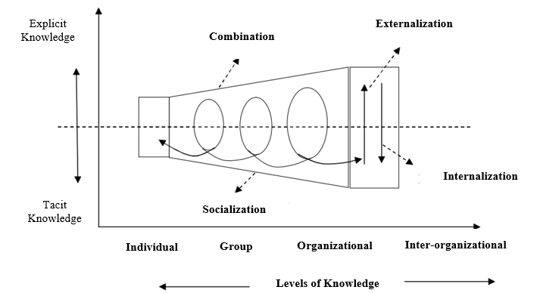
Figure 1.6: The SECI Process of Knowledge Conversion (Nonaka & Takeuchi)
Sourrce: Nonaka & Takeuchi (1995)
1.4 Proposed Research Model of Factors Influencing Knowledge Transfer in Vietnamese Enterprises
Proposed Research Model Each variable in the model holds a specific significance: Knowledge Source (KS); Organizational Structure (OS); Organizational Culture (OC); People (PE); Tools (TO). Below is the proposed research model, consisting of five independent variables and one dependent variable:
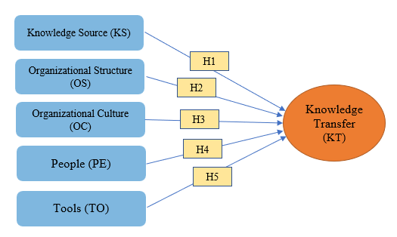
Source: Proposed by the author
Figure 1.7: Research Model of Factors Influencing KT in Vietnamese Enterprises
Research Hypotheses
- H1: Knowledge Source (KS) has a positive impact on Knowledge Transfer within Vietnamese enterprises.
- H2: Organizational Structure (OS) has a positive impact on Knowledge Transfer within Vietnamese enterprises.
- H3: Organizational Culture (OC) has a positive impact on Knowledge Transfer within Vietnamese enterprises.
- H4: People (PE) have a positive impact on Knowledge Transfer within Vietnamese enterprises.
- H5: Tools (TO) have a positive impact on Knowledge Transfer within Vietnamese enterprises.
CHAPTER 2: RESEARCH METHODOLOGY AND
OVERVIEW OF THE RESEARCH SUBJECT

2.1 Research Process and Methodology
2.1.1 Research Process
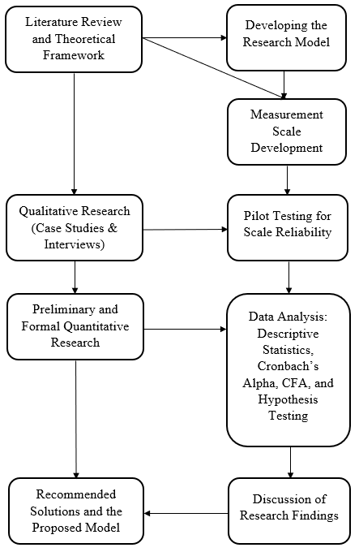
Source: Proposed by the author
Figure 2.1: The Research Process of the Dissertation
The research process of this dissertation is designed with a systematic and logical approach to ensure scientific rigor and alignment with the research objectives. The process commences with a comprehensive review of international and domestic literature regarding knowledge transfer. Through this review, five core factors were identified. Based on these factors, a research model was constructed featuring five independent variables and one dependent variable to examine their impacts within the Vietnamese context.
Subsequently, the author developed a 5-point Likert scale measurement instrument based on established previous studies, which was then adapted to fit the specific characteristics of Vietnamese enterprises. The research employs a mixed-methods approach:
- Qualitative Phase: Conducted through case studies and in-depth interviews with experts and corporate leaders. This phase aimed to clarify concepts, refine measurement scales, and explore context-specific factors such as collectivist culture and technological constraints prevalent in Vietnamese firms.
- Quantitative Phase: Following a pilot study, a formal survey was administered to 418 enterprises in Hanoi, Ho Chi Minh City, and Da Nang. The study utilized a combination of convenience and stratified sampling methods, with data collected both online and offline.
Data analysis involves evaluating Cronbach’s Alpha (>0.7) for reliability, Exploratory Factor Analysis (EFA), and Multiple Regression Analysis to determine the impact levels (Beta coefficients).

2.1.2 Research Methods
- Qualitative Research Method: The author initiates the process with a comprehensive literature review of domestic and international studies to establish a firm grasp of foundational theories. Furthermore, the qualitative approach involves discussing the quantitative results with industry experts to interpret their practical implications - for instance, exploring why technological tools exert the most significant impact during the current digital transformation era.
- Quantitative Research Method: The author conducts a broad survey across enterprises in Hanoi, Ho Chi Minh City, Da Nang, and other provinces, collecting data through a meticulously designed questionnaire featuring five independent variables and one dependent variable. The data is processed using SPSS software.
2.1.3 Data Collection Methods
2.1.3.1 Secondary Data Collection Method
The secondary data collection method involves extracting information from existing sources, including academic books, peer-reviewed journals, dissertations, research reports, statistical databases, and online documents from reputable organizations.
2.1.3.2 Primary Data Collection Method
a. Questionnaire Design The author developed a measurement instrument to evaluate five independent variables and one dependent variable using a 5-point Likert scale. The initial questionnaire was adapted from established previous studies and further refined through a two-step process to fit the Vietnamese corporate landscape:
- Expert Consultation
- Pilot Study
b. Data Collection Process Primary data was collected from September 2024 to December 2024 via an online survey hosted on Google Forms. The survey was distributed to enterprises in Hanoi, Ho Chi Minh City, Da Nang, and other regions, utilizing contact lists from the General Statistics Office and professional partners. Post-collection, the data was coded, imported into SPSS software, and meticulously screened for errors to establish a reliable dataset for analyzing the current state of knowledge transfer in Vietnam.
2.1.4 Sampling Method
The author applied a stratified random sampling method to ensure representativeness based on two criteria: geographical region and enterprise size (by labor force).
- By Geography
- By Labor Scale
Regarding the geographic distribution of the survey, although the actual number of enterprises in Ho Chi Minh City exceeds that in Hanoi, the thesis adjusted the sample proportions to ensure data feasibility and reliability. Specifically, Hanoi’s status as the political and administrative hub, coupled with the author’s established close contact networks and personal relationships, facilitated more favorable access to corporate email lists and Zalo groups. In contrast, while Ho Chi Minh City possesses the highest enterprise density nationwide, survey access encountered significant obstacles. This reflects an objective characteristic of the convenience sampling method in empirical research, aimed at optimizing the quality of collected data rather than representing intentional bias in the research design.
2.1.5 Sample Size
Based on two established formulas for determining sample size, the minimum requirements were calculated at 399 (according to Yamane) and 384 (according to Cochran).
The final sample size is manageable for data processing while remaining sufficiently robust to reflect the diverse reality of Vietnamese enterprises - ranging from small firms with a few dozen employees to large corporations with hundreds of staff.

2.1.6 Data Analysis Methods
The author utilized SPSS software to analyze the data through a rigorous scientific process, integrating quantitative and qualitative approaches to ensure both accuracy and practical significance.
- Reliability Analysis
- Exploratory Factor Analysis (EFA)
- Multiple Regression Analysis
- Qualitative Integration
2.2 Overview of Vietnamese Enterprises and Research Sample Characteristics
2.2.1 Overview of Vietnamese Enterprises
According to the Vietnam Enterprise White Paper 2024, there were 921,372 active enterprises nationwide, a 2.8% increase compared to 2022, reflecting robust resilience following global economic challenges. By the end of 2024, this figure reached approximately 940,078 enterprises (General Statistics Office, 2025), marking a growth rate of 4.8% over the previous year, according to state regulatory updates.
The structure of the enterprise sector shows a clear shift toward modern industries:
- Service Sector: Predominates with over 68% of the total, concentrated in commerce and retail. This sector requires extensive knowledge regarding consumer behavior and market trends.
- Industry and Construction: Accounts for approximately 30%, emphasizing manufacturing and infrastructure with a high demand for technical expertise.
- Agriculture, Forestry, and Fisheries: Represents only 1.3%, reflecting a significant transition away from traditional economic models (General Statistics Office, 2024).
In terms of ownership structure, Vietnamese enterprises are primarily private entities, such as Limited Liability Companies and Joint Stock Companies, accounting for over 85% of the total according to the Vietnam Enterprise Report 2024 (Ministry of Planning and Investment, 2025). State-Owned Enterprises (SOEs) and Foreign Direct Investment (FDI) firms comprise a smaller proportion - approximately 10-15% - yet play a pivotal role in knowledge transfer through international cooperation and advanced technology.
Regarding technological infrastructure, while Vietnamese firms are making progress, significant disparities exist between scales and regions, directly impacting knowledge transfer efficiency.
2.2.2 Research Sample Characteristics
Table 2.1: Characteristics of the Research Sample (N=418)
Data Characteristics | Frequency (n) | Percentage (%)
1. Geographical Distribution
Hanoi | 170 | 40.7%
Ho Chi Minh City | 120 | 28.7%
Da Nang | 70 | 16.7%
Others | 58 | 13.9%
2. Primary Sector of Activity
Science and Technology | 40 | 9.6%
Transportation and Logistics | 75 | 17.9%
Business and General Services | 105 | 25.1%
Finance | 50 | 12.0%
Information, Communication, and Entertainment | 38 | 9.1%
Manufacturing and Processing | 70 | 16.7%
Others | 40 | 9.6%
3. Type of Ownership/Legal Form
Limited Liability Company (LLC) | 190 | 45.5%
Joint Stock Company (JSC) | 60 | 14.4%
Partnership Company | 120 | 28.7%
Private Enterprise | 20 | 4.8%
State-Owned Enterprise (SOE) | 28 | 6.7%
4. Labor Scale (Number of Employees)
Under 50 | 150 | 35.9%
51 - 100 | 200 | 47.8%
101 - 300 | 40 | 9.6%
Above 300 | 28 | 6.7%
Total | 418 | 100.0%
Source: Compiled by the author from survey data
In synthesis, although the sample of 418 enterprises presented in Table 2.1 represents a fraction of the national total, its proportional distribution accurately reflects the prevailing trends and characteristics of the Vietnamese business landscape. International scholarship in knowledge management typically utilizes sample sizes ranging from 200 to 500 enterprises (Lin, 2007; Gold et al., 2001). Within the Vietnamese context, Nguyen & Tran (2019) employed a sample of 350 firms to evaluate knowledge management in SMEs, indicating that the sample size of 418 in this study is well within the appropriate range and carries high persuasive value.

CHAPTER 3: CURRENT STATUS AND ANALYSIS OF KNOWLEDGE TRANSFER ACTIVITIES IN VIETNAMESE ENTERPRISES
3.1 The Current State of Knowledge Transfer in Vietnamese Enterprises
3.1.1 Organizational Structural Characteristics and Knowledge Resource Constraints
Data indicates that micro and small enterprises (SMEs) in Vietnam are currently performing knowledge transfer (KT) at an Embryonic or Fragmented level. At this stage, the Externalization process is largely paralyzed. These enterprises operate based on "individual memory" rather than "organizational processes." This reflects the fragility of "institutional memory": when a business closes or personnel turnover occurs, the entire accumulated knowledge base is wiped out, forcing new market entrants to start from zero.
3.1.2 Technological Investment Capacity and the Innovation Gap
In the era of digital transformation, technology is considered a powerful lever for storing and distributing knowledge. Although Vietnam has made commendable progress in international rankings, the actual resource allocation for Research and Development (R&D) still shows a substantial gap compared to developed nations. This investment deficit creates a "hollow" in the innovation ecosystem, limiting the ability of firms to codify and leverage advanced intellectual property.
3.1.3 Cultural Barriers and Labor Productivity Pressures
Beyond technological factors, labor productivity is the most accurate metric reflecting the efficiency of knowledge application. The latest 2024 data continues to show that Vietnam requires extraordinary efforts to catch up with regional peers. Labor productivity acts as a mirror, precisely reflecting how well knowledge is integrated into production. A disparity gap of up to 9 times compared to Singapore and 3 times compared to Malaysia serves as a serious warning regarding the quality of economic growth.
3.1.4. Human Capital Quality and Absorptive Capacity
Current human resource quality constitutes a direct "bottleneck" hindering the knowledge absorption and transformation capabilities of Vietnamese enterprises. The low rate of trained labor (28%), combined with a significant digital skills gap compared to regional peers, has created a substantial cognitive barrier. This stagnation primarily affects the Internalization stage - the critical transition where organizational knowledge is converted into individual competence.
3.1.5. Organizational Culture and Policy Mechanisms
The lack of a sharing culture and supportive policy mechanisms acts as an invisible "choke point," causing disruptions in the knowledge flow. While enterprises can procure advanced Knowledge Management Systems (KMS), they cannot "purchase" the voluntary intellectual contribution of their workforce without a cultural environment rooted in trust and transparency. The absence of formalized knowledge transfer (KT) processes not only results in wasted technological investment but also stifles the potential for creative collaboration.
3.2 Survey Results on Factors Influencing Knowledge Transfer in Vietnamese Enterprises
3.2.1 Analysis of Independent Variables in the Model
3.2.1.1 Knowledge Source (KS)
Quantitative Results:
Table 3.6: Descriptive Statistics for Knowledge Source (KS)
Item Code | Description | Mean | Std. Deviation
KS1 | Knowledge within the enterprise is stored in a systematic and scientific manner. | 3.54 | 1.14
KS2 | Knowledge within the enterprise is easily accessible and usable by all employees. | 3.60 | 1.07
KS3 | Knowledge is regularly updated to ensure accuracy and practical relevance. | 3.66 | 1.02
KS4 | The enterprise possesses diverse knowledge sources from employees and partners who are willing to share. | 3.68 | 1.05
KS5 | Knowledge is organized in a way that is easy to understand and apply to practical tasks. | 3.60 | 1.05
Source: Compiled by the author from survey data
3.2.1.2 Organizational Structure (OS)
Quantitative Results:
Table 3.7: Descriptive Statistics for Organizational Structure (OS)
Item Code | Description | Mean | Std. Deviation
OS1 | The organizational structure is flexible with low hierarchy, facilitating knowledge transfer. | 3.53 | 0.97
OS2 | Departments coordinate closely and effectively in exchanging knowledge. | 3.62 | 1.01
OS3 | Knowledge transfer processes are clearly established and easy to implement within the organization. | 3.62 | 0.96
OS4 | Internal communication channels are convenient, supporting rapid knowledge transfer among employees. | 3.65 | 0.94
OS5 | The enterprise has a strategically oriented structure to promote knowledge transfer across departments. | 3.49 | 1.03
Source: Compiled by the author from survey data
3.2.1.3 Organizational Culture (OC)
Quantitative Results:
Table 3.8: Descriptive Statistics for Organizational Culture (OC)
Item Code | Description | Mean | Std. Deviation
OC1 | The enterprise encourages employees to transfer knowledge to colleagues naturally. | 3.12 | 1.40
OC2 | The corporate culture encourages knowledge transfer through clearly established core values. | 3.29 | 1.26
OC3 | The working environment is transparent and open, facilitating knowledge exchange. | 3.25 | 1.28
OC4 | Knowledge transfer is considered an integral part of the enterprise's core values. | 3.33 | 1.21
OC5 | The enterprise promotes learning and collaboration across departments to optimize knowledge. | 3.26 | 1.14
Source: Compiled by the author from survey data
3.2.1.4 People (PE)
Quantitative Results:
Table 3.9: Descriptive Statistics for People (PE)
Item Code | Description | Mean | Std. Deviation
PE1 | Employees possess sufficient knowledge and skills to share and receive knowledge from colleagues. | 3.43 | 0.97
PE2 | Employees are willing and proactive in transferring knowledge to those around them. | 3.53 | 1.04
PE3 | Interpersonal trust within the enterprise facilitates knowledge transfer. | 3.49 | 0.96
PE4 | Employees are encouraged to transfer knowledge through motivation and a positive learning environment. | 3.56 | 0.94
PE5 | Employees perceive that knowledge transfer contributes to the organization's collective goals. | 3.42 | 1.03
Source: Compiled by the author from survey data

3.2.1.5 Tools (TO)
Quantitative Results:
Table 3.10: Descriptive Statistics for Tools (TO)
Item Code | Description | Mean | Std. Deviation
TO1 | The enterprise utilizes tools (both technological and non-technological) for knowledge storage and transfer. | 3.83 | 1.04
TO2 | Employees easily access knowledge through tools such as IT systems or internal documents. | 3.85 | 1.03
TO3 | Information technology is designed to align with the actual work needs of employees. | 3.84 | 1.01
TO4 | Tools support effective communication and collaboration, such as tech platforms or team meetings. | 3.60 | 1.15
TO5 | The enterprise regularly improves tools to optimize knowledge management and transfer. | 3.69 | 1.07
Source: Compiled by the author from survey data
3.2.1.7 Summary Conclusion of Independent Variables
Tools (TO) emerge as the most potent driver of knowledge transfer in Vietnamese enterprises, propelled by the digital transformation wave. Knowledge Source (KS) is at a fair level but hindered by a lack of systematization. Organizational Structure (OS), People (PE), and Organizational Culture (OC) act as weaker enablers compared to TO and KS due to rigid hierarchies, lack of flexibility, insufficient motivation, and an uneven sharing culture.
3.2.2 Analysis of the Dependent Variable: Knowledge Transfer (KT)
Table 3.11: Descriptive Statistics for Knowledge Transfer (KT)
Item Code | Description | Mean | Std. Deviation
KT1 | Knowledge transfer helps the enterprise improve operational performance and labor productivity. | 3.62 | 1.06
KT2 | Knowledge transfer contributes to enhancing innovation and developing new products/services. | 3.68 | 1.08
KT3 | Knowledge transfer helps the enterprise minimize repeated mistakes and save operating costs. | 3.69 | 1.04
KT4 | Knowledge transfer enables employees to quickly adapt to changes and new working environments. | 3.58 | 1.14
KT5 | Knowledge transfer contributes to enhancing the enterprise's sustainable competitive advantage. | 3.74 | 1.18
Source: Compiled by the author from survey data
The overall Mean for KT is 3.66 (range: 3.58–3.74), indicating that knowledge transfer outcomes are at a fair level, reflecting a positive but not yet excellent contribution. The Standard Deviation (1.04–1.18) signifies moderate variance, implying that KT outcomes are inconsistent across enterprises. This aligns with Szulanski’s (2000) "Knowledge Stickiness" theory, where internal barriers lead to inconsistent results.
3.2.3 The Current State of Knowledge Transfer Tool Application in Vietnamese Enterprises
3.2.3.1 General Assessment of the Effectiveness of Knowledge Transfer Tools
Quantitative Results:
Table 3.12: General Assessment of Knowledge Transfer Tool Effectiveness
Effectiveness Level | Non-Technological Tools |  | Technological Tools
 | Frequency (n) | Percentage (%) | Frequency (n) | Percentage (%)
Very Effective | 67 | 16.0% | 215 | 51.4%
Effective | 157 | 37.6% | 134 | 32.1%
Neutral | 161 | 38.5% | 60 | 14.4%
Ineffective | 25 | 6.0% | 4 | 1.0%
Very Ineffective | 8 | 1.9% | 5 | 1.2%
Source: Compiled by the author from survey data
3.2.3.2 Usage Levels of Non-Technological Tools in Knowledge Transfer
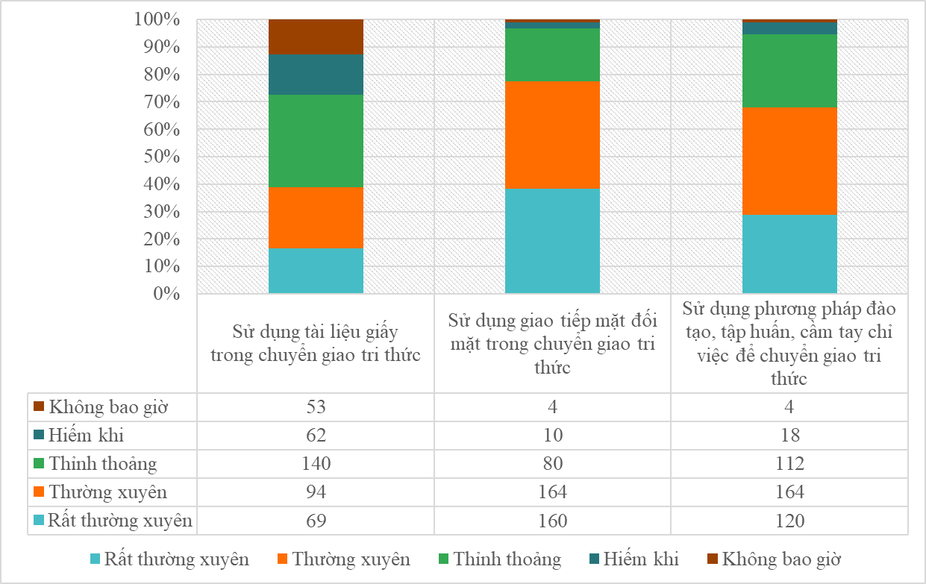
Source: Compiled by the author from survey data
Figure 3.9: Usage Levels of Non-Technological Tools in Knowledge Transfer
3.2.3.3 Usage Levels of Technological Tools in Knowledge Transfer
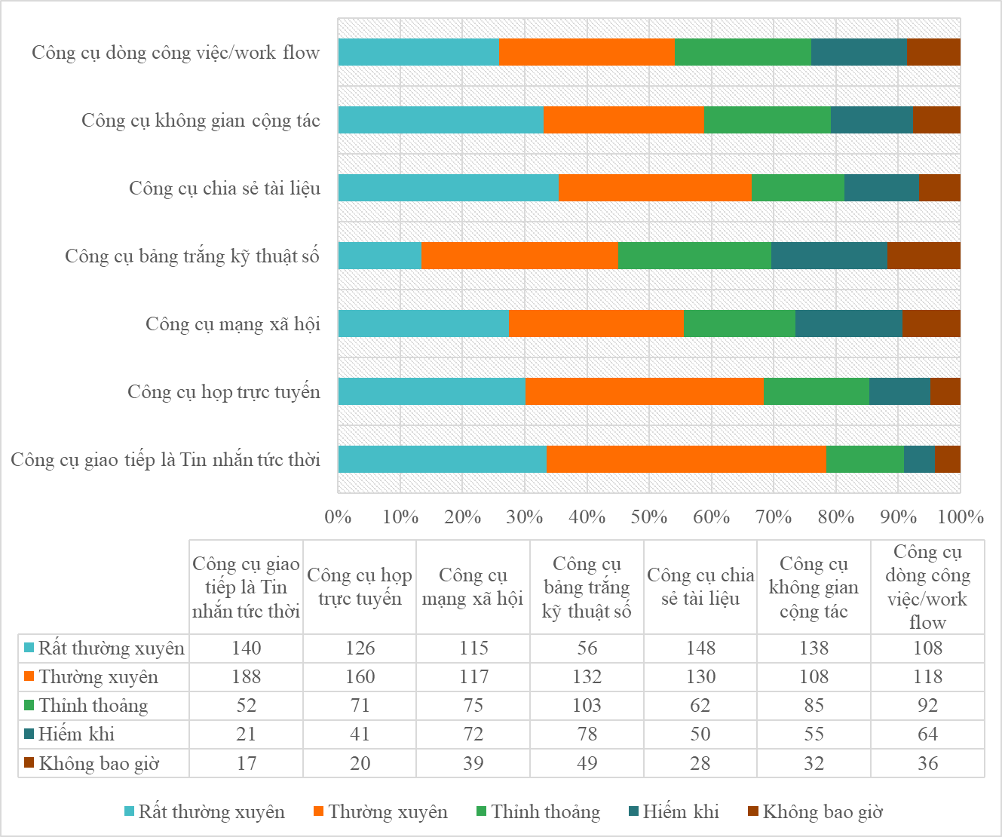
Source: Compiled by the author from survey data
Figure 3.10: Usage Levels of Technological Tools in Knowledge Transfer
Conclusion
The survey results provide a clear illustration of the current landscape of knowledge transfer tools within Vietnamese enterprises: Technological tools are markedly dominant, receiving robust support, while non-technological tools, though still present, are significantly overshadowed. However, the author contends that to truly optimize knowledge transfer, enterprises must adopt an intelligent hybrid approach. This involves strategically integrating both tool types: harnessing the scalability and agility of technology while preserving the irreplaceable interactive value and nuance provided by non-technological engagement.
3.2.4 Applying the SECI Model to Evaluate Knowledge Transfer in Vietnamese Enterprises
Socialization: The survey of 418 enterprises indicates that 77.5% utilize face-to-face communication and 68% organize training workshops, proving that Vietnamese firms possess a distinct strength in this stage, rooted in a collectivist culture.
Externalization: This is a prominent weakness for Vietnamese enterprises. Survey results show that only 39% utilize physical documentation, and advanced tools like internal databases or dedicated Knowledge Management Systems (KMS) are not yet widespread. While 59% use online collaborative spaces, there is a clear lack of investment in formalizing knowledge.
Combination: In Vietnam, this stage is at a moderate level: 78.5% of firms use basic communication platforms (Zalo, Skype) and 68.5% adopt virtual meetings. However, sophisticated tools like digital whiteboards (45%) or workflow management software (54%) remain underutilized.
Internalization: In Vietnamese firms, this stage achieves only average results: while 70% carry out knowledge transfer activities, only 30% rate the effectiveness as "high."
3.2.5 Overall Evaluation of Knowledge Transfer in Vietnamese Enterprises
Based on the survey findings, Vietnamese enterprises have achieved positive results in knowledge transfer, driven by investments in technology, infrastructure, and high-quality human resources. The responses reflect a favorable perception of transfer tools, the working environment, supportive policies, and the commitment of leadership. Activities such as professional training, workshops, face-to-face communication, and digital platforms are widely adopted, fostering a conducive environment for knowledge sharing and dissemination. These efforts have notably enhanced operational efficiency and organizational creativity.
3.3 Evaluating the Impact of Factors on Knowledge Transfer in Vietnamese Enterprises
3.3.1 Reliability Analysis
Table 3.13: Cronbach’s Alpha Reliability Results for the Scales
Measurement Scale | Number of Items | Cronbach’s Alpha
KS - Knowledge Source | 5 | 0.958
OS - Organizational Structure | 5 | 0.905
OC - Organizational Culture | 5 | 0.930
PE - People | 5 | 0.900
TO - Tools | 5 | 0.933
Source: Compiled by the author from survey data
3.3.2 Exploratory Factor Analysis (EFA)
3.3.2.1 Testing Data Adequacy
Table 3.14: KMO and Bartlett's Test Results
KMO and Bartlett's Test | Value
Kaiser-Meyer-Olkin Measure of Sampling Adequacy | 0.852
Bartlett's Test of Sphericity
Approx. Chi-Square | 10,791.671
df (degrees of freedom) | 300
Sig. (Significance level) | 0.000
Source: Compiled by the author from survey data
3.3.2.2 EFA Results for Individual Scales
- Knowledge Source (KS): Total Variance Explained = 85.763%; Factor loadings range from 0.909 (KS3) to 0.946 (KS5).
- Organizational Structure (OS): Total Variance Explained = 72.837%; Factor loadings range from 0.757 (OS5) to 0.905 (OS3).
- Organizational Culture (OC): Total Variance Explained = 78.354%; Factor loadings range from 0.840 (OC5) to 0.919 (OC2).
- People (PE): Total Variance Explained = 71.914%; Factor loadings range from 0.742 (PE5) to 0.901 (PE3).
- Tools (TO): Total Variance Explained = 79.317%; Factor loadings range from 0.862 (TO4) to 0.925 (TO3).

3.3.2.3 Overall EFA Results
Table 3.15: Rotated Component Matrix
Items | (KS) | (OC) | (PE) | (OS) | (TO)
KS5 | 0.877
KS1 | 0.871
KS2 | 0.851
KS4 | 0.816
KS3 | 0.797
OC2 |  | 0.874
OC3 |  | 0.866
OC1 |  | 0.865
OC4 |  | 0.855
OC5 |  | 0.790
PE3 |  |  | 0.899
PE2 |  |  | 0.894
PE4 |  |  | 0.841
PE1 |  |  | 0.808
PE5 |  |  | 0.617
OS3 |  |  |  | 0.905
OS2 |  |  |  | 0.876
OS4 |  |  |  | 0.868
OS1 |  |  |  | 0.847
OS5 |  |  |  | 0.755
TO2 |  |  |  |  | 0.813
TO3 |  |  |  |  | 0.813
TO1 |  |  |  |  | 0.775
TO5 |  |  |  |  | 0.666
TO4 |  |  |  |  | 0.584
Source: Compiled by the author from survey data
Analysis and Conclusion:
The EFA results demonstrate that all 25 observed variables are accurately grouped into five distinct factors: Knowledge Source (KS), Organizational Culture (OC), People (PE), Organizational Structure (OS), and Tools (TO).
3.3.3 Multiple Regression Analysis
3.3.3.1 Model Fit and Statistical Significance
- R^2 = 0.621; Adjusted R^2 = 0.616: This indicates that the model explains 62.1% of the variance in Knowledge Transfer.
- ANOVA: The F-test result (F = 134.980, df = 5/412, p = 0.000) confirms that the model is statistically significant at the 99% confidence level.
3.3.3.2 Regression Coefficients
Table 3.16: Multiple Regression Coefficients
Independent Variable | Un-standardized B | Std. Error | Standardized Beta (β) | t-value | Sig. (p) | Tolerance | VIF
(Constant) | -0.286 | 0.206 |  | -1.385 | 0.167
KS | 0.215 | 0.047 | 0.216 | 4.609 | 0.000 | 0.417 | 2.397
OS | 0.075 | 0.036 | 0.064 | 2.088 | 0.037 | 0.988 | 1.013
OC | 0.206 | 0.031 | 0.235 | 6.693 | 0.000 | 0.743 | 1.345
PE | 0.289 | 0.040 | 0.247 | 7.235 | 0.000 | 0.789 | 1.267
TO | 0.325 | 0.051 | 0.314 | 6.358 | 0.000 | 0.377 | 2.655
Source: Compiled by the author from survey data
3.3.4 Discussion of Results
Tools (TO - beta = 0.314): Emerging as the most potent driver, tools reflect the massive wave of digital transformation. Technology effectively bridges geographical gaps and standardizes knowledge flows.
- People (PE - beta = 0.247): Individual expertise and tacit experience remain the "lifeblood" of the organization, significantly determining the quality of knowledge being shared.
- Organizational Culture (OC - beta = 0.235): A culture that fosters trust and openness acts as the "oil" for the knowledge-sharing engine.
- Knowledge Source (KS - beta = 0.216): The richness and accessibility of knowledge assets provide the necessary "raw material" for transfer activities.
- Organizational Structure (OS - beta = 0.064): While significant, this factor has the weakest impact, likely due to the prevalent rigid hierarchies in Vietnam that sometimes impede rather than facilitate fluid knowledge exchange.

CHAPTER 4: RECOMMENDATIONS AND SOLUTIONS FOR PROMOTING KNOWLEDGE TRANSFER IN VIETNAMESE ENTERPRISES.
4.1 Forecasting Trends and Development Orientations for Knowledge Transfer in Vietnamese Enterprises
4.1.1 Trend Forecasting
The global Knowledge Management (KM) market is projected to surge from $59.6 billion (2023) to $164.8 billion by 2030 (CAGR 16.1%), underpinned by AI and Machine Learning (ML) integration. A pivotal shift toward AI-driven Knowledge Graphs is expected to yield a 36.4% CAGR, effectively mitigating "knowledge stickiness." Despite the rapid adoption of cloud-based collaboration tools (projected 70% market share), a significant digital divide persists, with only 35% AI implementation in developing nations.
In Vietnam, KM trends align with global shifts but are uniquely shaped by a collectivist culture and a robust legal framework. The domestic ML market is forecasted to reach $1.59 billion by 2033 (CAGR 32.78%), catalyzed by the National Digital Transformation Program and the Digital Data Law (2025). Major corporations (e.g., Viettel, FPT) have already demonstrated efficiency, reducing onboarding time by 60-70% via AI automation.
By 2030, Generative AI and institutional chatbots will be essential in bridging the generational gap as Gen Z occupies 24% of the workforce. Supported by a 10% rise in tech-focused FDI, Vietnam’s digital economy is positioned to contribute 30% to GDP, transforming individual expertise into sustainable organizational assets under a secure legal corridor.
4.1.2 Development Orientations for Vietnam
International and domestic research has significantly matured the field of knowledge transfer, providing robust methodologies and identifying critical success factors. In Vietnam, while its importance is recognized, most studies remain at an orientational level, lacking comprehensive management solutions.
Positive Achievements and Legal Framework: Vietnam has established a solid legal foundation, including: Law on Technology Transfer (2017) and Amended Law on Intellectual Property (2022); Digital Data Law No. 60/2024/QH15; Law on Science, Technology, and Innovation No. 25/2025/QH15; Resolution 57-NQ/TW (2024): Setting a target for the digital economy to reach 30% of GDP by 2030, with R&D investment at 2% of GDP, aiming for the Top 30 global innovation index by 2045.
Future Strategic Directions: Effective knowledge transfer has been proven to enhance efficiency (reducing repair/downtime by 15%) and drive innovation. To overcome current fragmentation, a comprehensive orientation is required: Legal Refinement: Finalizing regulations for the protection and transfer of digital knowledge assets; Infrastructure Investment: Accelerating 5G deployment and national data centers; Incentive Policies: Implementing tax incentives, innovation funds, and international cooperation programs to build a robust knowledge-based economy.
4.2 Recommended Solutions and Proposed Knowledge Transfer Model for Vietnamese Enterprises
4.2.1 Recommended Solutions to Enhance Knowledge Transfer
Solution 1: Developing an Integrated Digital Knowledge Management System (Focusing on KS and TO)
Survey results identify Knowledge Source (KS: 3.62) and Tools (TO: 3.76) as the strongest predictors of KT. However, the lack of systematic storage leads to "knowledge leakage," aligning with the "Knowledge Stickiness" theory (Szulanski, 2000) and "Technology Integration" (Gold et al., 2001). Implementing a Knowledge Management System (KMS) to categorize tacit and explicit knowledge, integrated with AI, is essential.
- Small Enterprises (<50 employees): Utilize Google Workspace (low-cost/free version); designate 1-2 key administrators; establish weekly shared repositories with automated reporting. Timeline: 3 months | Estimated Cost: <10 million VND; Expected Outcome: 20-30% productivity increase (Rašula et al., 2012).
- Medium Enterprises (51-300 employees): Deploy specialized KMS (e.g., SharePoint, Trello); conduct core knowledge audits; implement role-based access control. Timeline: 6 months | Estimated Cost: 50-100 million VND.
- Large Enterprises (>300 employees): Full-scale AI integration (e.g., IBM Watson/Custom ERP); deploy AI chatbots for instant expertise retrieval. Timeline: 9-12 months | Estimated Cost: 200-500 million VND.
Solution 2: Restructuring Organizational Culture and Framework (Focusing on OC and OS)
OC (3.25) and OS (3.58) received the lowest ratings, where "Silo" mentalities hinder innovation (KT2) and adaptability (KT4). This follows Davenport & Prusak (1998) on culture and Argote & Ingram (2000) on breaking organizational silos.
- Small Enterprises: Weekly sharing sessions; "Leading by example"; merit-based rewards for ideas. Timeline: 2-3 months | Cost: <5 million VND.
- Medium Enterprises: Establish cross-functional teams; leadership training; mandatory periodic knowledge exchange meetings.
- Large Enterprises: Transition to a Flat Structure; monthly open innovation forums; evaluate employees based on collaboration metrics. Timeline: 6-9 months | Estimated Cost: 100-200 million VND.
Solution 3: Enhancing Human Capacity and Intergenerational Transfer (Focusing on PE)
With PE (3.49) at a moderate level, the lack of motivation limits competitive advantage (KT5). Bridging the gap with Gen Z (24% of the workforce) requires "Deep Smarts" strategies (Leonard & Swap, 2005).
- Small Enterprises: Internal Leader-to-Staff mentoring; "Learning Diaries" for apprentices. Expected Outcome: 25% reduction in intergenerational knowledge loss.
- Medium Enterprises: Online learning portals combined with formal assessment; scheduled mentorship sessions between senior and junior staff.
- Large Enterprises: Comprehensive AI-driven training systems with AI-matching algorithms to connect mentors and mentees. Timeline: 6 months | Estimated Cost: 50-100 million VND.
Solution 4: Strengthening Inter-industry and Public-Private Partnerships
Internal limitations must be compensated by external networks.
- Small Enterprises: Active participation in VCCI/Industry Association workshops.
- Medium Enterprises: Formalize R&D partnerships (MOUs) with universities and research institutes.
- Large Enterprises: Leading national-level innovation programs; global technology transfer alliances. Expected Outcome: 25% increase in innovation capacity (WIPO GII, 2024).
4.2.2 Proposed Knowledge Transfer Model for Vietnamese Enterprises
The adaptation of the SECI model in this research focuses on redefining touchpoints to ensure compatibility with the Vietnamese corporate ecosystem, moving beyond mere theoretical application. The Socialization stage is optimized through informal spaces rooted in "relation-oriented" (trọng tình) culture, while Externalization is facilitated by "visual digitization" mechanisms to overcome psychological barriers to sharing. In the Combination and Internalization phases, Communities of Practice (CoPs) serve to dismantle hierarchical structures, enabling flexible horizontal knowledge circulation. These refinements transform SECI into a pragmatic execution toolkit aligned with the cost constraints, behavioral patterns, and innovation aspirations of the Vietnamese workforce. Detailed stages are presented below.
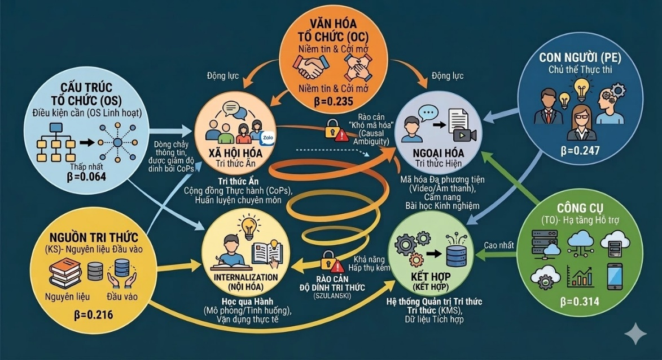
Figure 4.1: Proposed Knowledge Transfer Model for Vietnamese Enterprises
Source: Proposed by the author based on the regression analysis results in Chapter 3 and the theoretical synthesis of SECI and Szulanski frameworks.
4.3 Recommendations for State Management Agencies and Relevant Associations
4.3.1 Recommendations for the State
Ministry of Science and Technology: Refining the Legal Framework and Data Infrastructure; Establishing and operating the National Knowledge Portal; Institutionalizing protection mechanisms for "Tacit Knowledge" and technical know-how; Promoting the science and technology market.
Ministry of Information and Communications: Advancing Technological Infrastructure; Support programs for SMEs to implement Knowledge Management Systems (KMS); Standardizing national data formats.
Ministry of Education and Training in collaboration with the Ministry of Labour, Invalids and Social Affairs: Enhancing Human Capacity;Restructuring training programs based on the "Learning-by-doing" model; Establishing a National Network of Experts and Artisans.
Ministry of Finance and the State Bank of Vietnam: Encouraging Financial Mechanisms; Tax incentive policies for Knowledge Management expenditures; Innovation support funds specifically dedicated to Knowledge Transfer (KT).
4.3.2 Recommendations for Professional Associations
Vietnam Confederation of Commerce and Industry (VCCI): Leading Management Culture; Cultivating and disseminating a culture of sharing and trust; Engaging in policy advocacy and international networking.
Sector-Specific Associations (VITAS, VINASME, HAMI, etc.): Forming Horizontal Linkages; Establishing Cross-company Communities of Practice (CoPs); Developing industry-specific "Best Practice and Lessons Learned Databases."
Information Technology Associations (VINASA, etc.): Supporting Technological Infrastructure; Promoting "Tailor-made" Knowledge Management solutions; Providing consultancy and standardizing digital infrastructure.
The Bridge Role between Government - Industry - Academia: Facilitating the "Triple Helix" model (State - University - Industry) ; Organizing events to bridge the supply and demand for knowledge.

CONCLUSION
The thesis titled "Knowledge Transfer in Vietnamese Enterprises" is a systematic research endeavor aimed at resolving the challenge of leveraging intangible resources in the digital era. Throughout its execution, the author has fully realized the research objectives and achieved significant contributions on both theoretical and practical fronts. The core of this work lies in the successful integration of the SECI model with the "Knowledge Stickiness" theory to create a breakthrough analytical framework. This combination not only delineates the knowledge flow but also provides a diagnostic toolkit to identify disruptions at each transformation stage.
Theoretically, the thesis establishes and validates a five-factor impact model comprising: Knowledge Source, Structure, Culture, People, and Tools. Regression analysis results indicate that Tools (Beta = 0.314) and People (Beta = 0.247) are the two variables with the most profound influence on transfer efficiency. This finding underscores the pivotal role of digital infrastructure and the value of human subjects in decoding complex tacit knowledge. The model accounts for 62.1% of the variance in knowledge transfer activities, confirming its high applicability within the Vietnamese context.
Practically, through a survey of 418 enterprises, the study accurately identifies "bottlenecks" such as rigid hierarchical structures and the "knowledge hoarding" psychology. To mitigate these, the thesis proposes a synchronized ecosystem of solutions, notably the formation of Communities of Practice (CoPs) and the application of multimedia encoding. Investing in Knowledge Management Systems (KMS) and fostering a safe experimental culture are also highlighted as top priorities. These solutions ensure feasibility by aligning closely with national policies on the digital economy and the Digital Data Law.
Despite favorable results, the thesis acknowledges certain limitations, as the survey sample does not yet cover rural enterprises or specialized agricultural sectors. Furthermore, current measurements focus primarily on quantitative indicators, without deeply exploring qualitative values regarding long-term cultural perceptions of personnel. Future research should employ Structural Equation Modeling (SEM) to evaluate the cross-impact relationships among the five factors. Additionally, developing integrated measurement toolkits would help enterprises gain deeper insights into their innovation capabilities.
Knowledge transfer is not merely a technical procedure but a revolution in mindset and organizational culture within the digital economy era. This thesis aspires to serve as a valuable reference, helping domestic enterprises dismantle barriers to excel in the global race. The author recognizes that the work may still contain certain shortcomings and sincerely welcomes all feedback from the scientific community. Deepest gratitude is extended to the mentors, colleagues, and experts who supported the successful completion of this thesis.

